# Abstract

More than 100 tidal marsh creation projects have been constructed in the Fraser River Estuary, British Columbia, from the 1970s to present. Past studies described and evaluated many of these projects and found varied success, but the underlying factors that determine their outcomes have not yet been formally investigated. Using a combination of field sampling, spatial analysis, and statistical modeling, we aim to address this knowledge gap by asking what factors determine (1) if created marshes remain vegetated, and (2) the resilience of created marsh plant communities, measured by native species dominance and species richness. We observed recession in 40 of the 78 projects visited, representing 23,676 m2 (9.3%) of the 255,541 m2 of created marsh surveyed. Increases in mean site elevation had a negative effect on percent recessed area, while North Arm sites and sites further upriver were more prone to recession. Based on field observations and data interpretation we suggest that wake erosion and goose herbivory may be drivers behind these losses and warrant further investigation. Dominance of native species declined with distance upriver, though invasive cattail (*Typha angustifolia, T.* × *glauca)* defied this trend, dominating outer estuary sites when present. Native and non-native richness shared similar patterns and was comparable between reference and created marshes, increasing on average with elevation and distance upriver. These findings offer insight into the role that site design and location play in the outcome of marsh creation projects, and the challenges presented by stressors and environmental change in the estuary.

# Lay Summary

More than 100 tidal marshes have been constructed in the Fraser River Estuary over the last 40 years. Past reports described many of these projects and found varied success, but the factors behind these outcomes had not been investigated. We ask what factors influence (1) if a project remains vegetated, and (2) the resilience of a created marsh plant community, which we measure by the dominance and number of native plant species present. We observed marsh recession in 40 of the 78 created marshes visited, equalling approximately 23,676 m2 (9.3%) of the total created marsh area surveyed. We suggest these losses may be partly attributed to excessive grazing by Canada Geese and boat wake, and recommend future research to understand their impacts. Sites that were lower in elevation, further upriver, and located in the North Arm averaged higher amounts of recession. Native species were less dominant with distance upriver, while the diversity of species increased with elevation and distance upriver. Basin designs appear to be more resilient to grazing and erosion but are more likely to be invaded by non-native cattail and sustain less diverse plant communities. This study offers insights into the role of design and location in the outcome of projects, and the sheds lights on some of the challenges of tidal marsh creation in the estuary.

# Acknowledgements

This report was made possible through funding from the B.C. Wildlife Federation Wetlands Workforce project, which was supported through the provincial Healthy Watersheds Initiative. Data collected in 2015 was facilitated by the Community Mapping Network and B.C. Conservation Foundation and funded through the National Wetland Conservation Fund. We also wish to thank the Community Mapping Network for hosting compensation site data on their BIEAP-FREMP Atlas, as this was an essential starting place for both 2015 and 2021 surveys.

The authors extend thanks to landowners who allowed entry to compensation marshes during 2015 and 2021 surveys. This includes Metro Vancouver Regional District, the Vancouver Fraser Port Authority (VFPA), Vancouver Airport Authority, Pacific Custom Logistics, Ladner Yacht Club, S&R Sawmills Ltd., Blue Heron Marina Estates, and the B.C. Ministry of Forests, Lands, Natural Resource Operations and Rural Development (MFLNRORD).

With gratitude we wish to acknowledge the time and expertise offered by reviewers of this report. These include Gary Williams (G L Williams & Associates Ltd.), Mark Adams (Envirowest Consultants Inc.), Krista Forysinski (Fisheries and Oceans Canada), Robert Sambrook (Fisheries and Oceans Canada), Yeganeh Asadian (xʷməθkʷəy̓əm [Musqueam] Indian Band), Shane Byrne (MFLNRORD), Vanessa Koo (VFPA), and Charlotte Olson (VFPA). We also thank Sean Boyd (Environment and Climate Change Canada) and Dominic Janus (University of British Columbia [UBC]) for their input on Canada Geese in the estuary. Finally, we wish to thank Johnny Xi and Biljana Stojokova (UBC Applied Statistics) for guiding us in the development of our models.

**Table of Contents**

Abstract i

Lay Summary ii

Acknowledgements iii

List of Tables vi

List of Figures vii

1 Introduction 1

2 Methods 4

2.1 Field Sampling 4

2.2 Spatial Data 6

2.3 Statistical Analysis 7

2.3.1 Marsh Recession 7

2.3.2 Native Dominance 7

2.3.3 Species Richness 8

3 Results 8

3.1 Marsh Recession 8

3.2 Relative % Cover of Native Species in Created Marshes 10

3.3 Species Richness of Fraser Estuary Marshes 12

4 Discussion 14

4.1 Marsh Recession Mechanisms & Mitigation Strategies 14

4.2 Elevation & Sea Level Rise 17

4.3 Invasive Species 19

4.4 Monitoring Implications 20

4.5 Site Design Trade-offs 21

4.6 Data Limitations, Caveats, & Future Research 22

5 Conclusion 23

Data Availability Statement 25

Works Cited 26

Appendix 31

Appendix A: Reference Marsh Descriptions 32

Appendix B. Species List from 2015 and 2021 Vegetation Surveys 34

Appendix C: Photo Examples of Marsh Recession 38

Appendix D: Photo Examples of Closed Embayment Sites 38

Appendix E. Response and Predictor Variable Descriptions 39

Appendix F. Summary Statistics of Recession Model Variables 41

Appendix G. Marsh Recession Model Summary Table 41

Appendix H. Marsh Recession Model Visualizations 42

Appendix I. Summary Statistics of Native Dominance Model Variables 43

Appendix J. Native Dominance Model Summary Table 43

Appendix K. Native Dominance Model Visualizations 44

Appendix L: Summary Statistics of Richness Model Variables 46

Appendix M. Native Richness Model Summary Table 46

Appendix N. Native Richness Model Visualizations 47

Appendix O. Non-Native Richness Model Summary Table 49

Appendix P. Non-native Richness Model Visualizations 50

# List of Tables

Table 1. Examples of potential pros and cons of various created tidal marsh design elements 21

Table 2. Descriptive information of reference sites included in this study. 32

Table 3. List of macrophytes observed in plots during 2015 and 2021 vegetation surveys with accompanying origin status (N = Native, E = Exotic, I = Invasive). For cryptic species where origin could not be determined, origin status is ‘U’. Non-native species were classified as invasive if in our judgement they demonstrate the ability to outcompete and displace native plant communities in tidal marsh habitats. 34

Table 4. Descriptions of response and predictor variables included in this study. 40

Table 5. Summary statistics for all variables included in the marsh recession model. Continuous data are summarized using minimum, maximum, mean, and standard deviation values, while categorical data show the number and relative frequency of each variable. 41

Table 6. Model summary for the marsh recession model, including model estimates, confidence intervals, *p*-values, number of observations, and *R*2 values. 41

Table 7. Summary statistics for all variables included in the native dominance model. Continuous data are summarized using minimum, maximum, mean, and standard deviation values, while categorical data show the number and relative frequency of each variable. 43

Table 8. Model summary for the native dominance model, including model estimates, confidence intervals, *p*-values, number of observations, and *R*2 values. 43

Table 9. Summary statistics for all variables included in the native and non-native richness models. Continuous data are summarized using minimum, maximum, mean, and standard deviation values, while categorical data show the number and relative frequency of each variable. 46

Table 10. Model summary for the native richness model, including model estimates, confidence intervals, *p*-values, number of observations, and *R*2 values. 46

Table 11. Summary statistics for all variables included in the non-native richness model. Continuous data are summarized using minimum, maximum, mean, and standard deviation values, while categorical data show the number and relative frequency of each variable. 49

# List of Figures

Figure 1. Map of assessed tidal marsh creation projects and reference marshes in the Fraser River Estuary (2021: *n* = 36; 2015: *n* = 58; total *n* = 96). 5

Figure 2. Scatter plots and box and whisker plots displaying the distribution of data for each independent variable used in the marsh recession model. Box and whisker median values are shown by the middle horizontal line of each box plot, separating the upper box (2nd quartile) and lower box (3rd quartile). 9

Figure 3. Coefficients for independent variables included in the site-based percent recessed marsh model (left) and plot-based relative percent cover native model (right). Coefficients right of 0 (blue) indicate positive effects, and those located to the left of zero (red), indicate negative effects. Within each panel, coefficients are ordered from the most to least positive effects. Coefficients with statistically significant effects are noted with asterisks (p < .001 ‘***’, .01 ‘**’, .05 ‘*’). Error bars represent 95% confidence intervals. 10

Figure 4. Scatter plots and box and whisker plots displaying the distribution of data for each independent variable used to model relative percent cover of native species/plot. Box and whisker median values are shown by the middle horizontal line of each box plot, separating the upper box (2nd quartile) and lower box (3rd quartile). Distance upriver (bottom left) and channel proximity (bottom centre) were included as interacting terms with elevation, which we have visualized by showing the interactions relative to low (< [mean - σ]), average (mean), and high (> [mean + σ]) maximum elevation values. 11

Figure 5. Scatter plots and box and whisker plots displaying the distribution of data for each independent variable used to model native richness/plot (left) and non-native richness/plot (right). Box and whisker median values are shown by the middle horizontal line of each box plot, separating the upper box (2nd quartile) and lower box (3rd quartile) Distance upriver was included as an interaction term with elevation in both models (bottom row), which we have visualized by showing the interactions relative to low (< [mean - σ]), average (mean), and high (> [mean + σ]) maximum elevation values. 13

Figure 6. Model coefficients for fixed effects included in native richness (left) and non-native richness (right) models. Coefficients right of 0 (blue) indicate positive effects, and those located to the left of zero (red), indicate negative effects. Within each panel, coefficients are ordered from the most to least positive effects. Coefficients with statistically significant effects are noted with asterisks (p < .001 ‘***’, .01 ‘**’, .05 ‘*’). Error bars represent 95% confidence intervals. 14

Figure 7. Bar plot (left) showing the number of created marsh sites (closed embayments [*n* = 11] other [*n* = 67]) per grazing intensity class, based on field notes and photos taken in 2015 (Lievesley at al. 2016) and this study (2021) Classes were defined as “None” (no evidence of herbivory), “Low” (occasional clipped plants), “Moderate” (widespread clipping), and “High” (community altering). Boxplot (right) showing the maximum Lyngbye’s sedge height per plot in inland sites versus non-inland created marshes. 16

Figure 8. Visualisation of biotic coastal squeeze. Reed canarygrass is present in many of the high elevation marshes of the Fraser Estuary (A) and is likely resilient to increased inundation stress once established. As rising sea levels force the retreat of native marshes, their comparatively low competitive ability, and inability to move upslope may lead to their disappearance (B). 18

Figure 9. Scatterplot showing the percent frequency of plots of four known invasive species in the Fraser Estuary with increasing distance upriver (left) and the relative percent cover of those species, when present in a plot (right). Data were collected from created and reference marshes in the FRE by Lievesley et al. (2016) and in 2021. Loess regression lines display non-parametric trends in the scatterplot data. 19

Figure 10. Photos of sites containing recessed marsh, based on the definitions of this study. Project boundaries are displayed with red lines, and marsh extent with yellow. Areas between the red and yellow lines were classified as recessed. Photos taken by D. Stewart on and 6 May (top) and 31 May (bottom) 2021. 38

Figure 11. Photos of closed embayment sites. Note the debris fence located at the marsh outflow in the top image, and the engineered drainage channel in the bottom image. Outflow locations are displayed with yellow stars. Photos taken by R. Ingham on and 22 July (top) and 24 June (bottom) 2021. 39

Figure 12. Plots displaying how the expected dependent variable (% recessed marsh) changes as a function of each model predictor (x-axis), while all other model variables are held fixed. The expected value is displayed with the blue line, 95% confidence interval for the expected value with the grey band, and partial residuals with red dots. This and all subsequent plots in Appendices J,M & O were created using visreg package in R (visreg, ‘visreg’ package; Breheny & Burchett 2017) 42

Figure 13. Plots displaying how relative % cover of native species changes as a function of each model predictor (x-axis), while all other model variables are held fixed. The expected value is displayed with the blue line, 95% confidence interval for the expected value with the grey band, and partial residuals with red dots. 44

Figure 14. Cross sectional plots displaying the fit of a model with an interaction between % distance upriver and elevation (top) and channel proximity and elevation (bottom) on relative % cover of native species in sample plots. Continuous elevation data are placed into one of three cross-sections: 10th percentile (red), 50th percentile (green), and 90th percentile (blue), and the expected value of each cross-section is displayed by regression lines. Positive and negative residuals are located on the top and bottom axes. 45

Figure 15. Plots displaying how native richness changes as a function of each model predictor (x-axis), while all other model variables are held fixed. The expected value is displayed with the blue line, 95% confidence interval for the expected value with the grey band, and partial residuals with red dots. 47

Figure 16. Cross sectional plot displaying the fit of a model with an interaction between % distance upriver and elevation. Continuous elevation data are placed into one of three cross-sections: 10th percentile (red), 50th percentile (green), and 90th percentile (blue). The expected value is displayed by regression lines. Positive and negative residuals are located on the top and bottom axes. 48

Figure 17. Plots displaying how non-native richness changes as a function of each model predictor (x-axis), while all other model variables are held fixed. The expected value is displayed with the blue line, 95% confidence interval for the expected value with the grey band, and partial residuals with red dots. 50

Figure 18. Cross sectional plot displaying the fit of a model with an interaction between % distance upriver and elevation. Continuous elevation data are placed into one of three cross-sections: 10th percentile (red), 50th percentile (green), and 90th percentile (blue). The expected value is displayed by regression lines. Positive and negative residuals are located on the top and bottom axes. 51

# Introduction

Human settlement has occurred in estuaries for millennia as they contain productive arable land and abundant natural resources, and are in close proximity to the ocean (Small & Nichols 2003; Fitzpatrick et al. 2015). The result, particularly in recent centuries as human populations have exponentially increased, has been the escalated alteration, fragmentation, and loss of estuarine habitats around the world. These losses have led to declines in the function, services, and resilience of these ecosystems in an age in which threats such as climate change, sea-level rise, and species invasions abound (Dahl 1990; Vitousek et al. 1997; Barbier et al. 2011; O’Meara et al. 2017). To this day, habitat loss continues to be one of the major threats to global estuaries, as coastal human populations continue to increase (Kennish 2002).

Estuaries along the West Coast of North America have not been immune to these losses. Brophy et al. (2019) estimated that 85% of vegetated tidal wetlands have been lost from estuaries along the contiguous U.S. Pacific Coast, with the greatest losses occurring in major river deltas. The Fraser River Estuary (FRE), the largest estuary on Canada’s Pacific Coast, has seen similar wetland losses, estimated between 70–90% since European settlement (Hoos & Packman 1974; Boyle 1997; Dorcey 2004). These losses are detrimental to many species that depend on these habitats, including declining Pacific salmon populations that use tidal marshes as foraging and refuge habitat during juvenile life stages (Levy & Northcote 1982; Chalifour et al. 2019, 2021) and numerous species at risk (Kehoe et al. 2021). The north-south network of estuaries along the Pacific Coast also provides critical stopover points for migratory bird species travelling along the Pacific Flyway, and productive foraging, resting, and roosting habitat for migratory and resident waterfowl, shorebirds, songbirds, and gulls (Butler & Campbell 1987; Sutherland et al. 2013).

As awareness around the impacts of human activities in estuaries have increased, so too have efforts to counteract them. In the FRE, significant research occurred in the late 1970s and early 1980s to understand the ecology of tidal marshes (e.g., Bradfield & Porter 1982; Levy & Northcote 1982), and to investigate tidal marsh creation as a means of curtailing habitat loss (Boyd 1979). Building upon this knowledge, tidal marsh creation escalated with the introduction of the 1986 *Policy for the Management of Fish Habitat*, which contained guidelines for achieving no net loss (NNL) of the productive capacity of fish habitats in Canada (DFO 1986; Adams & Williams 2004; Bradford et al. 2017). According to the Policy guidelines, unavoidable fish habitat losses[1] would henceforth be balanced by habitat replacement on a project-by-project basis. The primary means of offsetting these losses and achieving NNL was habitat compensation, which depended on the creation of marsh habitats to offset unavoidable losses. Marsh creation projects continue to be proposed and approved in the FRE under the current *Fisheries Act* and Fish Habitat Protection Policy Statement (2019), but differ in no longer adhering to past NNL guidelines, and the term “compensation” has been replaced by “offsetting” (Bradford et al. 2017; DFO 2019). Within this regulatory context over 100 compensation or offset projects were completed in the FRE from the 1980s to present, representing nearly all attempts at tidal marsh habitat creation in the region to date.

A small number of reports have documented and even evaluated the functioning of these marsh creation projects, each suggesting that success was not universal. In summer of 1992, Kistritz et al. (1992) noted that some habitat compensation sites were degraded by erosion and driftwood accumulations, likely due to ineffective shear booms or erosion protection. Based on created project area, Kistritz (1995) found that a net gain of brackish marsh habitat occurred in the FRE from 1983 – 1992 due to compensation activities; however, follow-up remediation was still recommended at a number of failed sites. Levings and Nishimura (1996) compared the functioning of transplanted, natural (reference) and disrupted (unvegetated) marshes in the FRE and found that the average percent cover of Lyngbye’s sedge (*Carex lyngbyei*) in created tidal marshes sites was less than 50% of that observed in reference sites, while transplanted sites had overall higher rush (*Juncus* spp.) cover. Invertebrate abundance was also compared and was frequently higher in created marshes than reference marshes. Although no differences were found in Chinook salmon (*Oncorhynchus tschawytscha*) and chum salmon (*O. keta*) fry among sites, smolt catches were significantly different, with often higher catches at disrupted sites. Adams and Williams (2004) provided a more recent summary of these projects, noting that early marsh-creation efforts were more prone to failure, likely due to inappropriate species selection and poor quality assurance during site preparation and planting. Lievesley et al. (2016) evaluated a subset of FRE projects based on vegetated area and native plant dominance, though these were not the criteria by which these projects were assessed by regulators. They found that of the 54 marshes visited in their study, 65% achieved their intended vegetated marsh area, and 50% of sites possessed marsh vegetation comparable in native dominance to neighbouring reference sites.

These reports described in detail the status of created tidal marshes, but to our knowledge no research has attempted to investigate the mechanisms behind their success or failure in the FRE. One of the challenges to such an investigation is definingproject “success”, as this word is imprecise, often controversial in ecology, and the definition can vary among organizations and individuals (Kentula 2000; Zedler & Callaway 2000). This disunity is further compounded by a lack of standardized monitoring protocols in the region, which several authors have already brought to light (Levings 2000; Adams & Williams 2004; Bradford et al. 2017). For the purposes of this report, we deviate from the yes/no terms of “success” or “failure”, acknowledging that even “failed” sites possess ecological values, and instead focus on “persistence”, which we define as the ability of these projects to function as native tidal marshes within the greater environmental context of the FRE.

Vegetative cover is commonly used to evaluate created tidal marshes, and is a success metric employed in FRE monitoring programs (Kentula 2000; Zedler & Callaway 2000; Adams & Williams 2004; Broome et al. 2019). Functioning tidal marshes support high levels of net primary production (NPP), that over time accumulates in the form of soil organic matter. This organic surface soil horizon is an integral part of the detritus-based food web of estuaries. For this reason, as well as refuge offered by aboveground biomass, vegetative cover has historically been used as a proxy for high-quality fish habitat in the region (Levings 2004a; Bradford et al. 2017). In addition to providing food and refuge for numerous other species, tidal marshes provide a multitude of ecological services, including soil stabilisation, water quality maintenance, wave attenuation, carbon sequestration, and nutrient cycling (e.g., Peterson et al. 2008; Broome et al. 2019; Forysinski 2019; Arias-Ortiz et al. 2021; Correa et al. 2021).

Species composition can greatly influence the ecological functions and services of a plant community (e.g., Haines & Hanson 1979; Jessop et al. 2015; Alldred & Baines 2016; Forysinski 2019). The abundance of invasive species is regularly used to monitor site function, as they can displace native flora over large areas, and may subsequently alter the structure, biodiversity, productivity, and food webs of wetlands (Zedler & Kercher 2004). Though few in number, studies that have investigated the effects of invasive species in the FRE support this. D are known to beLyngbye’s sedge, (Grout et al. 1997) Non-native cattail, especially hybrid *Typha* × *glauca* currently occupies an estimated 4% or 500,000 m2 of tidal marsh habitats in the FRE, forming near monocultures where established (Stewart 2021). This ongoing cattail invasion may represent a major disruption to biodiversity and food web interactions in the FRE, as monocultures are significantly less floristically diverse, and contain fewer chironomids and overall benthic invertebrates than nearby sedge meadows (Lee 2021; Stewart 2021).

Diversity is another metric of composition that may offer insights into the resilience and functioning of a tidal marsh (Levings 2004b). Diverse plant communities have been shown to be more temporally stable, higher functioning, and potentially more resilient to environmental change than less diverse ones (Tilman 1997; Naeem 1998; Allan et al. 2011), but do not always lead to increases in services (Jessop et al. 2015).

A second obstacle to investigating the mechanisms behind the resilience of these projects is the complexity of such an analysis, which requires consideration of the design, environmental context, and regulatory measures of a given project. Project designs vary considerably in the FRE from elevated marsh benches, to dike breaches, to embayments, each differing in size, shape, elevation, age, planting prescription, and degree of protection from debris and erosion. Each site also occurs in a unique environmental context, being influenced by a combination of abiotic (e.g., saltwater influence, tidal influence, debris accumulation) and biotic factors (e.g., herbivory, invasive species), that vary based on location in the estuary, and elevation. The regulatory environment of each project is also unique, and based on measures committed to by proponents in their respective *Fisheries Act* Authorization applications. Upon acceptance from Fisheries and Oceans Canada (DFO), these measures were monitored and approved after a determined monitoring period.

The objective of this study was to advance our understanding of marsh habitat creation and management in the FRE by learning from the successes and failures of over 40 years of projects. This is motivated by a recent surge of interest among stakeholders in the estuary to build new habitats and enhance past projects. Examples of such initiatives include an upcoming large-scale dike breach in the Alaksen Wildlife Area (Ducks Unlimited Canada [DUC]), tidal marsh creation with the upcoming Iona Wastewater Treatment Plant upgrades (Metro Vancouver Regional District), and prioritisation planning for the enhancement of past projects (DFO, DUC). To achieve this, we used a combination of field sampling, spatial analysis, and modelling to investigate key factors that contribute to the outcome of projects. Specifically, we asked:

1. Which factors are associated with marsh recession in created tidal marshes?
2. Which factors influence the dominance of native species in created marshes?
3. Which factors influence plant community diversity in created and natural tidal marshes?

# Methods

## Field Sampling

This study includes data from 78 marsh creation projects constructed between 1982 – 2015, and 16 reference marshes located in the FRE, southwest British Columbia (Fig. 1). Among these are 51 projects and 7 reference sites surveyed in 2015 by Lievesley et al. (2016), whose data we include and build upon with an additional 27 projects and 9 reference sites surveyed between June – August 2021. Wetland reference sites may vary in selection criteria depending on study objectives (Kentula 2000), and for the purposes of this report we define reference sites as tidal marshes that to our knowledge were not significantly disrupted by human activity in recent decades, and were not constructed (see Appendix A for reference site details). Many of the marsh sampling methods presented here were adapted from 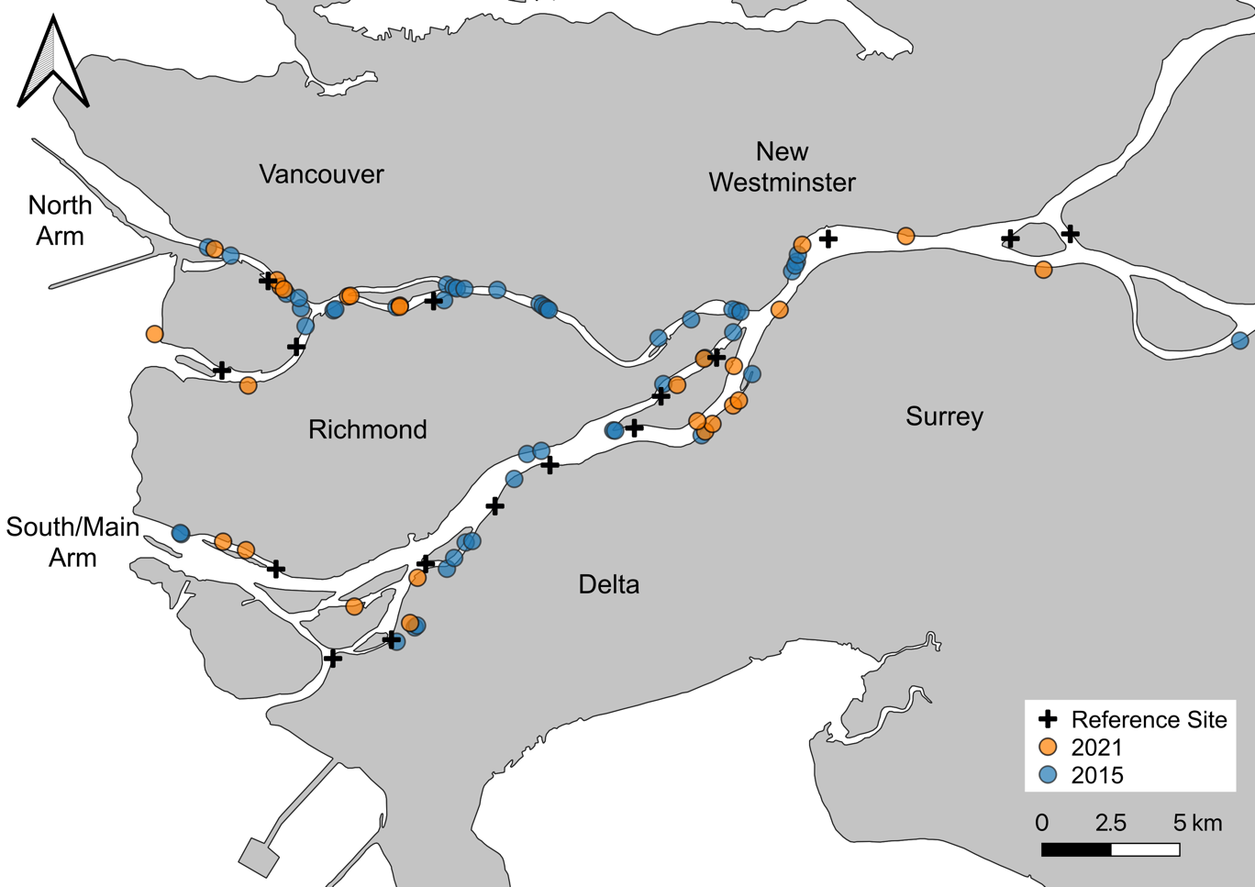Lievesley et al. (2016) to maintain consistency between datasets.

Figure 1. Map of assessed tidal marsh creation projects and reference marshes in the Fraser River Estuary (2021: *n* = 36; 2015: *n* = 58; total *n* = 96).

Created tidal marshes were located using a combination of desk- and field-based reconnaissance, correlating project descriptions and photographs provided in the BIEAP-FREMP Atlas (CMN 2021) with field observations and imagery. Randomized sampling plots were generated in advance of site visits using a random plot generator in QGIS (3.20, QGIS Development Team 2021), with all plots separated by at least 3 m. We targeted an optimum sample size of 20 plots per site (James-Pirri et al. 2007), though occasionally fewer were sampled due to tide/time constraints, or in cases where sites were too small to contain the target number of plots. Each plot entailed a 1 x 1 m quadrat oriented perpendicular to the nearest major channel, typically the Fraser River. Surveyors recorded the aerial percent cover of all living macrophytes originating from within the quadrat, as well as exposed substrates (i.e., litter, mud, rock, debris). Percent cover estimates were permitted to exceed 100% in cases where foliar cover of species overlapped significantly. Each species was then classified into one of four origin classes: native, introduced (invasive), introduced (non-invasive), and unknown. No definitive invasive species list exists for the estuary, so non-native species were classified as invasive if in our judgement they demonstrate the ability to outcompete and displace native tidal marsh plant communities (see Appendix B for a list of all species observed, and their respective origin classes). Plot data were then used to calculate species richness and relative percent cover data for each plot. Relative percent cover is defined as the cover of a given species or grouping of species as a percentage of the total plant cover in a plot, and was used to account for seasonal bias in our sampling, and high variability of plant forms and densities in our study area.

In addition to vegetation sampling, we mapped the boundary of each marsh creation project using a combination of handheld GPS units (Garmin GPSMap® 64s) and Apple iPad mini (5th generation) with Avenza Maps mapping software and 10 cm resolution georeferenced imagery (3.14.1; Avenza Systems Inc. 2021). Vegetated areas, unvegetated mudflats, and log debris accumulations within the intended marsh area were also mapped, and the presence other site features were noted, such as the presence of debris fences, functional foreshore shear booms, and other structures (i.e., docks, log storage booms) located immediately offshore.

## Spatial Data



***Recession in Created Marshes***

We defined marsh recession as areas within tidal marsh creation projects (red line above) that were intended to be vegetated in their original design but were primarily absent of vegetation during 2015 or 2021 surveys (e.g., area between red and yellow lines above). To ensure the accuracy of these estimates, we referred to a combination of available historical imagery, site plans, monitoring reports, and photos to delineate planted areas. As visualised in the photo above, these recessed areas were often located along the marsh leading edge.

Spatial analyses were used to describe the condition and environmental context of plots and sites. Project area was calculated using site polygons that were mapped in the field and was defined as the marsh boundary of a given project. Where original project descriptions, design schematics, or photographs were available, these were also used to aid in delineating site boundaries. We found that most created marshes visited in this study had clear project boundaries (e.g., rip-rap perimeter), and thus we are confident in these calculated project areas. We calculated the percent of recessed marsh in each project by dividing the area of recessed marsh mapped in the field by the total project area. For the purposes of this study, recessed marsh was defined as areas within tidal marsh creation projects that were intended to be vegetated in their original design but were primarily absent of emergent vegetation during 2015 or 2021 surveys (inset right; see Appendix C for examples). We calculated percent edge habitat for each site by using the Measurement Tool in QGIS to calculate the area of marsh located within 5 m of the river channel, which we then divided by the project area. Each site was assigned a distance from the river mouth, which was calculated as the channel-distance from each site to a standardized line across the mouth of the Fraser. In cases where multiple pathways to the river mouth were possible, distances were based on those of the largest, and therefore most influential, channel. Elevation data were acquired from a digital elevation model (DEM) derived from a publicly available 2016 LiDAR dataset (GeoBC, 2021; vertical accuracy +/- 15 cm RMSE, horizontal accuracy +/- 65 cm RMSE) and were used to calculate both mean site elevation, and sample plot elevation in QGIS. For each sample plot, proximity to channel was calculated in QGIS using the GRASS Toolbox (7.8.6; GRASS Development Team 2012).

## Statistical Analysis

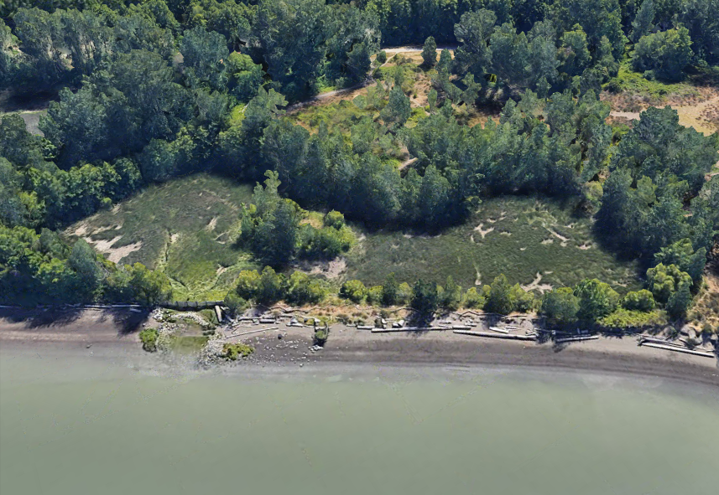

***Closed Embayment Designs***

Twelve of the 78 created tidal marshes included in this study were classified as “closed embayment” designs. These projects are often excavated behind dikes and are connected to the river via engineered outlets, such as the site pictured above (FREMP# 03-004, CPR# 9303-0041). Inland sites vary in size and shape from narrow channels to large basins. By design, inland sites have very little exposure to external stressors such as erosion and herbivory, but may suffer from other factors such as shading, poor drainage, log debris entrapment, and invasive species.

### Marsh Recession

We used a multiple linear regression model in R to evaluate the effects of various factors on marsh recession in created marshes (lm, ‘stats’ package in R; R Core Team 2021). Percent recessed marsh, which was derived from our spatial analyses, was used as the dependent variable. Independent variables were selected for their potential relationship to marsh recession based on our professional judgement, and data availability. These included categorical variables such as river arm, presence of a foreshore shear boom, presence of offshore structures (i.e., log storage booms, dock structures), placement in a slough, and closed embayment design (inset left; see Appendix D for examples). Numeric independent variables included project age, project size, distance upriver, percent edge habitat, and mean project elevation (see Appendix E for a detailed description of each model variable)

Outflow

### Native Dominance

To determine which factors influence the dominance of native species in created marshes, we modeled the relative % cover of native species/plot using a linear mixed-effects model (‘lmer’, “lme4” package in R; Bates et al. 2015). Sample plot data from created marshes were used for this analysis. Independent variables were selected based on data availability, and evidence in the literature of their relevance to plant species distributions in estuaries. These included plot distance upriver (a proxy for saltwater and tidal stress), plot elevation, plot distance to nearest channel, and age of the created site. River arm and enclosed embayment were included as categorical variables. Sampling year and sites were included as random effects to account for potential sampling differences between 2015 and 2021 datasets, and to account for site-to-site variation. We included two interaction terms in the model: (1) plot distance upriver with plot elevation and (2) plot channel proximity with plot elevation, as we anticipated the effects of distance upriver and channel proximity on native dominance would be dependent on elevation.

### Species Richness

We used linear mixed-effects models to investigate factors that influence native and non-native species richness across the estuary (‘lmer’, “lme4” package in R; Bates et al. 2015). Native richness/plot and non-native richness/plot were used as dependent variables. These richness models differed from the native dominance model, as they included plot data from both reference sites and created marshes. As a result, model variables differed in the addition of a categorical variable to distinguish between reference and created marshes, and the removal of site age, since the age of reference marshes could not be estimated. An interaction term between plot distance upriver and plot elevation was included in both richness models, as we expected the effect of distance upriver on richness to be dependent on elevation.

All models were evaluated for collinearity using variance inflation factors (VIF; vif, “car” package in R; Fox & Weisberg 2019). No model variables exceeded our VIF threshold of 5.0, indicating no significant collinearity was present (James et al. 2013). Model assumptions and fit were assessed through data visualizations, including residual plots to ensure no obvious patterns were present and quantile-quantile (QQ) plots to ensure approximate normality. Fit was also evaluated using adjusted *R*2 values for the marsh recession model, which evaluates the degree to which a response variable is explained by the model while also accounting for the number of independent variables. The *R*2 values of the plot-based linear mixed-effect models were reported using methods described by Nakagawa and Schielzeth (2013) using the “MuMIn” package in R (r.squaredGLMM; Bartoń 2020). A significance threshold of .05 was used to evaluate the significance of model variables. All statistical analyses were performed using R version 4.0 (R Core Team 2021).

# Results

## Marsh Recession

Recessed marsh ranged from 0–100% across the 78 created tidal marshes, averaging 13.8% (SD = 21.7%). This equates to approximately 23,676 m2 or 9.3% of the 255,541 m2 of created tidal marsh sampled. Two sites (3%) were entirely unvegetated mudflat, while 38 (49%) had no observable recession. Sites varied considerably in their numeric variable ranges: distance upriver (0.4–46.9 km), age (7–40 years), size (20–59,309 m2), mean elevation (-0.4–2.2 m) and proportion of edge habitat (0.0–100%; Fig. 2). Among categorical variables in the 78 sites, 9 (12%) had a functional shear boom present, 25 (32%) had an offshore structure, 17 (22%) were in sloughs, 12 (15%) were closed embayments, and 35 (45%) were in the North Arm (see Appendix F for summary statistics of these variables).

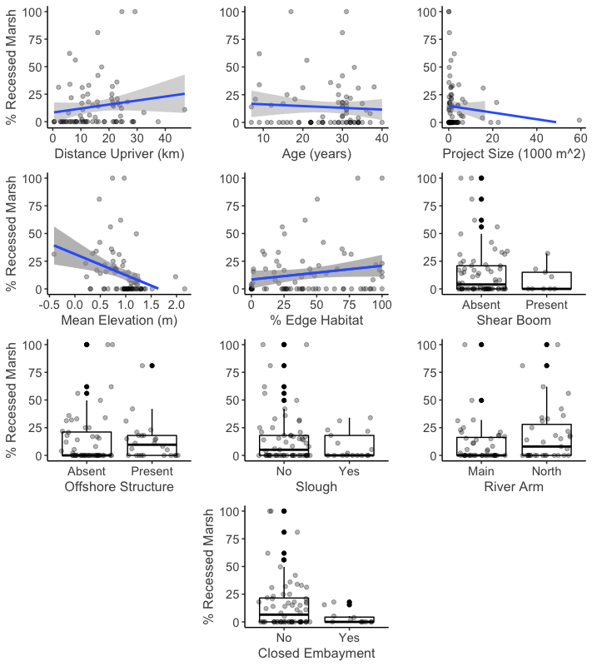Figure 2. Scatter plots and box and whisker plots displaying the distribution of data for each independent variable used in the marsh recession model. Box and whisker median values are shown by the middle horizontal line of each box plot, separating the upper box (2nd quartile) and lower box (3rd quartile).

Sites with higher elevations were less susceptible to recession (*p* < .001), as recession declined by 27% on average for every metre gained in mean site elevation (*F* [10,67] = 3.092*,* adj. *R2 =* 0.214, *p* = .003; Fig. 3). Recession was positively correlated with distance upriver (*p* = .002), averaging a 1% increase per kilometre upriver, and sites in the North Arm experienced 13% more recession on average than sites in the Main Arm (*p* = .017). Though not statistically significant in their effect, there are indications that factors related to the protection of sites (i.e., located in a slough, embayed design, shear boom present, offshore structure present) may mitigate recession. Project size, project age, and percent of edge habitat had no significant effect on recession (see Appendixes G & H for model summary and visualizations).

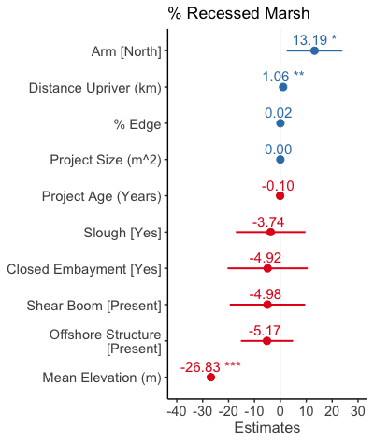

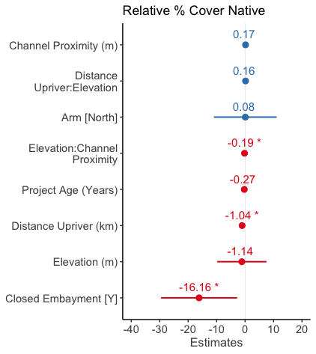

Figure 3. Coefficients for independent variables included in the site-based percent recessed marsh model (left) and plot-based relative percent cover native model (right). Coefficients right of 0 (blue) indicate positive effects, and those located to the left of zero (red), indicate negative effects. Within each panel, coefficients are ordered from the most to least positive effects. Coefficients with statistically significant effects are noted with asterisks (p < .001 ‘***’, .01 ‘**’, .05 ‘*’). Error bars represent 95% confidence intervals.

## Relative % Cover of Native Species in Created Marshes

A total of 1244 vegetation plots sampled in created marshes were included in this model, with 850 plots sampled at 51 sites in 2015, and 394 plots sampled at 28 sites in 2021 (Fig. 4). No reference site plot data were included, as we wanted to include project age as a variable, which is specific to created tidal marshes[2]. Numeric plot data represented a wide range of brackish and freshwater created tidal marsh conditions: channel proximity (0–201 m), project age at time of sampling (2–37 years), distance upriver (0.4–46.9 km), elevation (-0.77– 2.80 m). Among categorical variables, 524 (42%) of plots were in the North Arm, and 273 (22%) were in closed embayments (see Appendix I for detailed summary statistics). Relative percent cover of native species ranged from 0 – 100% in the sample plots, averaging 60.2% (SD = 35.8%). Sampling effort was similar among years in created marshes, averaging 16.7 plots/site in 2015 and 14.6 plots/site in 2021.

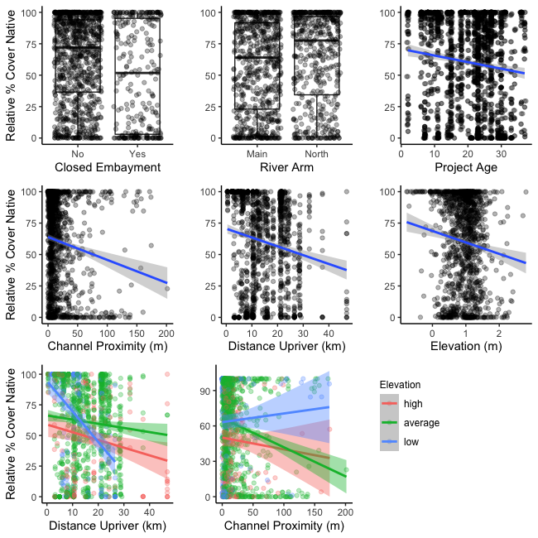

Figure 4. Scatter plots and box and whisker plots displaying the distribution of data for each independent variable used to model relative percent cover of native species/plot. Box and whisker median values are shown by the middle horizontal line of each box plot, separating the upper box (2nd quartile) and lower box (3rd quartile). Distance upriver (bottom left) and channel proximity (bottom centre) were included as interacting terms with elevation, which we have visualized by showing the interactions relative to low (< [mean - σ]), average (mean), and high (> [mean + σ]) maximum elevation values.

Distance upriver (*p =* .018) and closed embayments (*p* = .019) were found to negatively affect native dominance, as plots averaged a decrease of over 1% per kilometer upriver and were on average 16% lower in closed embayments than non-embayed marshes (marginal *R*2 = 0.083, conditional *R*2= 0.42; Fig. 3). The significant interaction between elevation and channel proximity suggests that mid to high elevation plots generally experience steeper declines in native dominance with distance from channels than low elevation plots (*p* = .018; Fig. 4). Project age, river arm and elevation had no significant effect on native dominance. Though no significant interaction was observed between distance upriver and elevation, there are indications that low elevation plots may experience greater declines in native dominance with distance upriver than mid to high elevation plots (see Appendixes J & K for model summary and visualizations).

## Species Richness of Fraser Estuary Marshes

A total of 1716 sample plots were included in richness models, with 1244 originating from 79 created marshes (see 3.2 for more details). The remaining 472 originated from 16 reference marshes (Fig. 1), with 292 sampled in 2015 and 180 sampled in 2021. Reference sites were sampled with greater intensity in 2015 than 2021, averaging 42 plots/sites across 7 sites, versus 20.0 plots/site across 9 sites in 2021. Numeric plot data encompassed a wide range of marsh conditions: channel proximity (0–201 m), distance upriver (0.4–46.9 km), elevation (-0.77–2.80 m). Among categorical variables, 651 (38%) of plots were in the North Arm, 472 (28%) occurred in reference marshes, and 273 (16%) were in closed embayments (see Appendix.L for detailed summary statistics).

Native richness ranged from 0–13 species/plot, averaging 3.7 species/plot (SD = 2.4). A total of 107 native plant species were observed in plots, including at-risk Henderson’s checker-mallow (*Sidalcea hendersonii*)and American sweetflag (*Acorus americanus*;see Appendix B for comprehensive species list). Elevation (*p* <.001) and distance upriver (*p =* .028) had significant positive effects on native richness, with an average increase of 0.9 native species/plot with each metre of elevation gained, and 0.1 native species/plot with each kilometer upriver (marginal *R2*= 0.081, conditional *R*2= 0.421; Fig. 6). Plots located in closed embayment marshes on average contained 1.45 fewer native species/plot than non-embayed marshes (*p* <.001). The placement of a plot within a reference site had no significant effect on native richness, nor did river arm, channel proximity, or an interaction between distance upriver and elevation (see Appendixes M & N for model summary and visualizations).

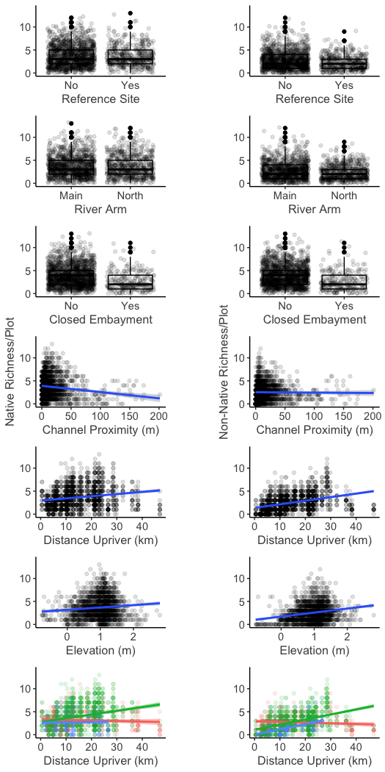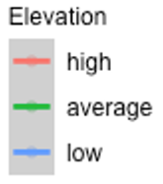

Figure 5. Scatter plots and box and whisker plots displaying the distribution of data for each independent variable used to model native richness/plot (left) and non-native richness/plot (right). Box and whisker median values are shown by the middle horizontal line of each box plot, separating the upper box (2nd quartile) and lower box (3rd quartile) Distance upriver was included as an interaction term with elevation in both models (bottom row), which we have visualized by showing the interactions relative to low (< [mean - σ]), average (mean), and high (> [mean + σ]) maximum elevation values.

Non-native richness ranged from 0–12 species/plot, averaging 2.5 (SD = 1.9) over the study area. A total of 74 non-native plant species were observed in plots. Similar to native richness, non-native richness was positively correlated with elevation (*p* < .001) and distance upriver (*p* <.001; marginal *R*2 = 0.180, conditional *R*2 = 0.506; Fig. 6). A significant interaction between these variables (*p* < .001) suggests that the effects of distance upriver on non-native richness is dependent on elevation. Average and low elevation plots appear to increase in non-native richness with distance upriver, whereas high elevation plots experience minimal change (see Fig. 5 for visualized interactions). Channel proximity was also positively correlated with non-native richness, with an average increase of 1 non-native species/plot per 100 m distance from the nearest channel (*p* = .024). Unlike native richness, the placement of plots in closed embayments did not have a significant adverse effect on non-native richness, though there is inconclusive evidence that plots located in embayments and reference sites may be prone to lower non-native richness (see Appendixes O & P for model summary and visualizations).

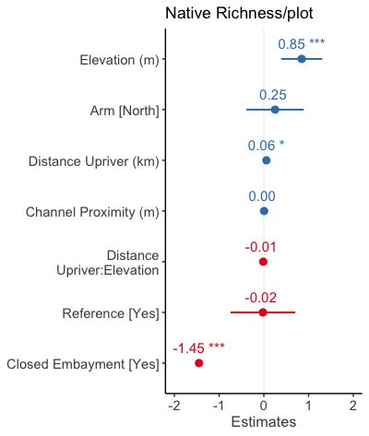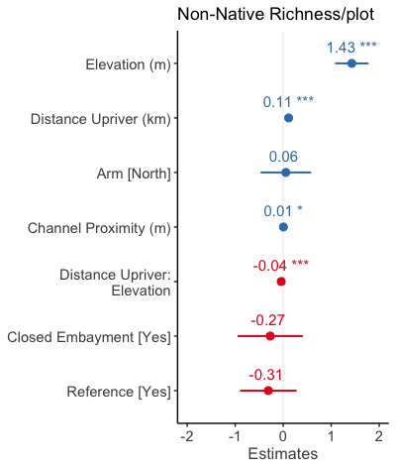

Figure 6. Model coefficients for fixed effects included in native richness (left) and non-native richness (right) models. Coefficients right of 0 (blue) indicate positive effects, and those located to the left of zero (red), indicate negative effects. Within each panel, coefficients are ordered from the most to least positive effects. Coefficients with statistically significant effects are noted with asterisks (p < .001 ‘***’, .01 ‘**’, .05 ‘*’). Error bars represent 95% confidence intervals.

# Discussion

## Marsh Recession Mechanisms & Mitigation Strategies

We found that marsh recession is frequent in created marshes of the FRE, occurring in 40 (51%) of the 78 projects included in this study, representing an estimated 23,676 m2 of total recessed marsh. Similar to recession occurring in the natural marshes of the delta front, isolating a lone driver for these losses is unlikely, as there are presumably several contributing and interacting factors leading to plant mortality (Balke 2017; Marijnissen & Stefan 2017). Examples may include erosion from vessel wake and river processes, sediment deficiency, poor project design and implementation, herbivory by invasive Canada Geese *(Branta canadensis*)*,* sea-level rise, and shading by bridge structures or neighbouring riparian vegetation.

Results of our marsh recession model suggest that projects protected from erosional processes are likely to experience less recession than exposed sites. Placement of sites in a slough, closed embayment designs, and foreshore protection through use of sheer booms and other offshore structures were all negatively correlated with marsh recession to varying degrees, though results remain inconclusive. Natural riverine processes may be a factor behind these erosional losses (Kistritz et al. 1992), but also vessel wake, which to our knowledge has yet to be assessed in the FRE but is known to be a driver behind erosion and marsh recession in other coastal regions (Nanson et al. 1994; Houser 2010; Bilkovic et al. 2017, 2019; El Safty & Marsooli 2020). The erosional effects of boat wake is not a new proposition to the FRE, as it has been already noted as a threat to some projects in the FRE, and has motivated the installation of protective offshore log booms (Kistritz et al. 1992; Adams & Williams 2004) and the strategic planting of the densely-rhizomatous *Juncus balticus* along the leading edge of at least one project (G. Williams, personal communication, December 2021).

Further evidence of wake impacts may be the significant difference in recession observed between the Main Arm and North Arm, with North Arm projects averaging 13% more recessed area per site. Boat wake energy is primarily influenced by channel morphology (depth, width) and vessel characteristics (frequency, length, depth, speed), which differ between river arms (Glamore 2008; Bilkovic et al. 2019; El Safty & Marsooli 2020). Based on morphology the North Arm appears to be more vulnerable to wake impacts, as it is both shallower and narrower than the Main Arm, allowing less distance for wave energy to dissipate before reaching the shore (Nanson et al. 1994; Bilkovic et al. 2019). As for vessel characteristics, the Main Arm downstream of the Pattullo Bridge is designated and maintained as a deep-sea shipping channel, supporting both small and large boats, including ocean-going container ships and automobile carriers. The North Arm differs in being designated as a *domestic* navigational channel, supporting small and mid-sized boats such as tugs, barges, and pleasure crafts that are possibly in greater densities than the Main Arm. Currently the differences in type, frequency and even speed of vessels between river arms remains poorly understood, but may, in addition to the above geomorphological characteristics, be a contributing factor to marsh recession.

In addition to erosion, the negative correlation between closed embayments and recessed marsh may also point to herbivory by Canada Geese as a contributing factor. Canada Geese have already been attributed to planting mortality and failure in several tidal marshes in the FRE (Kistritz 1995; Adams & Williams 2004), and sedge marsh losses in other pacific northwest estuaries (Crandell 2001; Dawe et al. 2015). Herbivory was noted in more than half of the 76 created marshes that were visited in this study (two were excluded because they were unvegetated and cause was uncertain), with high (i.e., community altering) impacts observed in 11 (14%), moderate (i.e., widespread clipping) in 30 (39%), and low (i.e., occasional clipping) in 18 (24%) of sites (Fig. 7). Inland marsh designs may offer a strategy for mitigating herbivory, as these sites are generally less suitable for Canada Geese, who rely on foreshore tidal flats and large channels to enter marshes, generally avoid enclosed areas where tall vegetation or human structures obscure their vision and rely on large open areas for take-off. Our data support this hypothesis, as 9 out of 12 (75%) of inland sites visited in our surveys had no visible sign of herbivory, and none were graded as moderate or high intensity. Maximum *C. lyngbyei* leaf height data from vegetation plots also appear to be slightly higher in closed embayments than those exposed to river channels (Fig. 7).

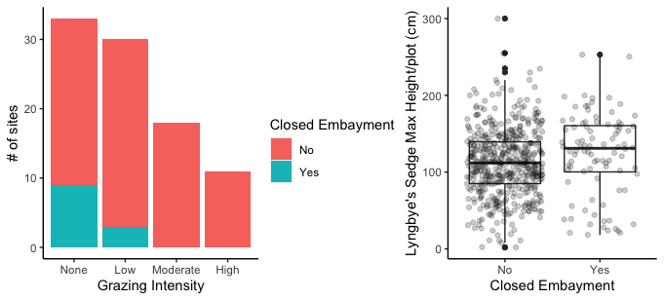

Figure 7. Bar plot (left) showing the number of created marsh sites (closed embayments [*n* = 11] other [*n* = 67]) per grazing intensity class, based on field notes and photos taken in 2015 (Lievesley at al. 2016) and this study (2021) Classes were defined as “None” (no evidence of herbivory), “Low” (occasional clipped plants), “Moderate” (widespread clipping), and “High” (community altering). Boxplot (right) showing the maximum Lyngbye’s sedge height per plot in inland sites versus non-inland created marshes.

The positive correlation between both North Arm sites and distance upriver with recession may also provide evidence of herbivory impacts. The seasonal distribution and abundance of Canada Geese in the FRE are not well documented, but they are known to feed, breed, and moult up and down the estuary even though the majority of tidal marsh habitat occurs at the delta front[3]. Marsh habitat is increasingly rare and fragmented as you move upriver, and the North Arm is more deficient than the South Arm (Levings 2004a). The highly-fragmented habitat “oases” of the North Arm and upper estuary, many of which are tidal marsh creation projects, may be subject to higher grazing intensity due to a lack of neighbouring habitat to dissipate these impacts, leading to the overexploitation of a plant community (Kondoh 2003), and due to disrupted predator-prey relationships, which are more likely to occur in small habitat fragments (Genua et al. 2017).

Unexpectedly, we found that project size and proportion of edge habitat did not have a significant effect on marsh recession, suggesting that large projects do not equate to recession resilience. This finding fails to support the prevailing opinion that larger projects are more resilient to external stressors due to their size, but does not discount their value, for example larger habitats may support more natural processes, habitat features (e.g., tidal channels) and overall heterogeneity than small sites, potentially supporting higher diversity (Larkin et al. 2008; Hood 2020).

## Elevation & Sea Level Rise

We found mean site elevation to be a significant predictor of marsh recession, with an average decrease in percent recessed area of 26% for every metre gained. To a degree this may simply reflect the environmental limits of tidal marsh species, as emergent vegetation ceases to grow at certain low elevation thresholds (Cronk & Fennessy 2001). However, it may also be linked to the sensitivity of low elevation plant communities, which already occur in stressful environments, to disturbance. Many marsh species survive prolonged inundation and anoxic soil conditions using specialized tissue (aerenchyma), which delivers oxygen from emergent foliage to their root systems. However, clipping by Canada Geese may be essentially cutting off the “snorkel” of these low elevation species, thereby inducing stress by reducing both photosynthesis, and oxygen transport to the anoxic root zone. Depending on severity, this added stress may result in reductions of fitness and even mortality of vegetation, as shown in the use of similar mechanical cutting to manage problematic wetland species such as cattail (Johnson et al. 2019) and reed canarygrass (Klimešová 1994). These impacts to vegetation, which include mortality, clipping/thinning of aboveground biomass, or grubbing of root systems, may also amplify erosional losses, particularly in low elevation marshes where there is prolonged exposure to these processes (Coops et al. 1996a).

Coastal squeeze is a term used to describe the loss of intertidal habitat due to sea-level rise and other factors, while the high water mark is fixed by a dike or other defence infrastructure (Pontee 2013). We propose another form of localised coastal squeeze may also occur, as in some situations rising sea levels may force the retreat of native marsh communities into high elevations dominated by established invasive species (Fig. 8). This is evidenced by our richness data, which although positively correlated with elevation, appears to be symmetric and unimodal, peaking around 1 m elevation (Fig. 5). This departs from the prevailing pattern of richness increasing with elevation in estuaries (Cronk & Fennessy 2001), which occurs as the environment is further removed from environmental stress (e.g., tidal submergence, salinity) and is thus able to support a larger pool of non-specialist species (Engels & Jensen 2009). This suggests that the species-rich elevations of the estuary are currently constrained by environmental stress at low elevations, and another, unknown factor in upper elevations. Second, we found that both native and non-native richness generally increased with distance upriver, but this trend was less pronounced in high elevations, which appear to remain stable throughout the estuary (Fig. 6). Though only observational, we believe that reed canarygrass may represent this upslope barrier, as (1) we have observed it as a dominant species in nearly all parts of our study area, particularly in mid- to high-elevation marshes where salinity and tidal stresses are reduced, and (2) among invasive species only it and cattail are known to form dense monodominant stands in the estuary (Fig. 9).

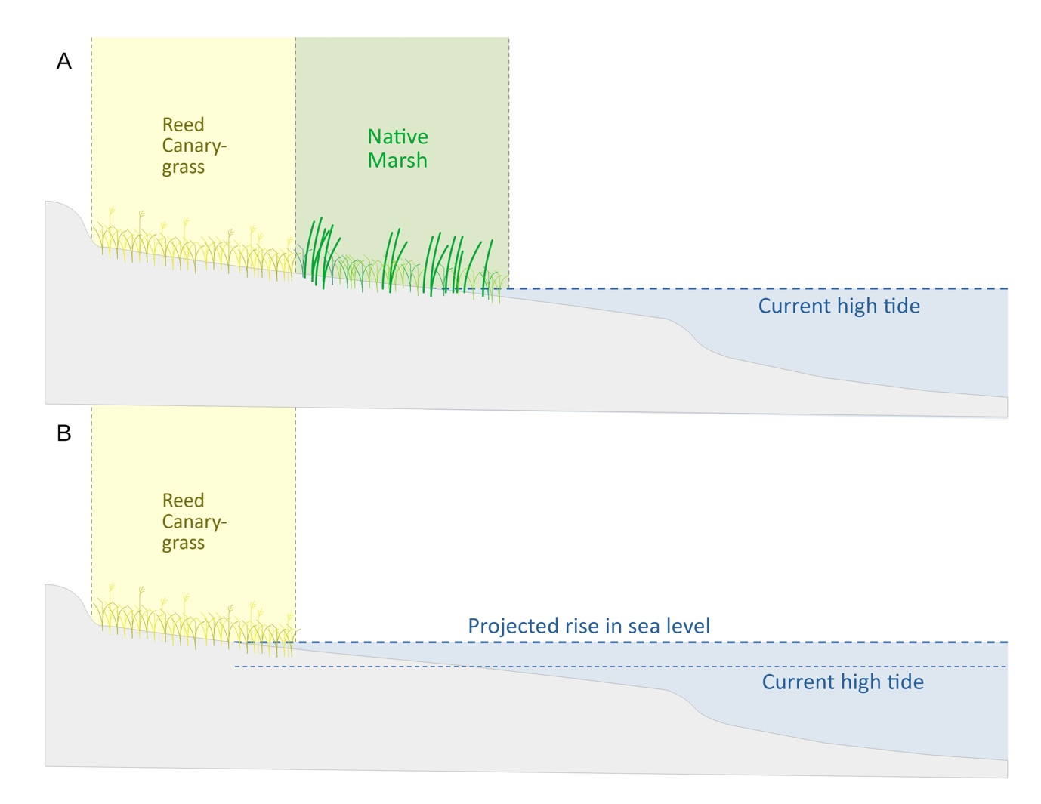

Figure 8. Visualisation of biotic coastal squeeze. Reed canarygrass is present in many of the high elevation marshes of the Fraser Estuary (A) and is likely resilient to increased inundation stress once established. As rising sea levels force the retreat of native marshes, their comparatively low competitive ability, and inability to move upslope may lead to their disappearance (B).

The ability of reed canarygrass to function as a biotic barrier to native marsh retreat is dependent on its resilience to future conditions, which is yet to be evaluated. Resilience will likely depend on future site-specific characteristics such as hydroperiod, soil properties, and elevation. Studies have found reed canarygrass to be tolerant of periodic flooding, and in some cases, flooding may even enhance growth, particularly in nutrient-rich environments such as estuaries. This high tolerance may be attributed to high levels of root airspace, high shoot lengths, and adaptable morphology (Klimešová 1994; Miller & Zedler 2003; Kercher & Zedler 2004). Prolonged submergence (> 4 weeks) has been shown to adversely affect productivity (Coops et al. 1996b; Miller & Zedler 2003; Jenkins et al. 2008), but there are likely few marshes that possess these inundation regimes in the FRE due to its tidal nature.

## Invasive Species

Relative percent cover of native species decreased at an average rate of 1% per kilometre upstream, a trend that correlates with the percent frequency per site data of invasive plants in our surveys (Fig. 9). The high invasion resilience of marshes near the delta front can likely be attributed to environmental stress, which excludes competitive generalists and facilitates the dominance of a small number of native specialists, such as common three-square bulrush (*Schoenoplectus pungens*)and Lyngbye’s sedge (Cronk & Fennessy 2001; Crain et al. 2004). A larger pool of non-native species are able to establish eastward, as evidenced by the positive correlation between non-native richness and distance upriver. These increases are likely the result of reductions in environmental stress (Engels & Jensen 2009; Borde et al. 2020), and high competitive ability (Crain et al. 2004), coupled with ongoing anthropogenic and natural riverine disturbances (e.g., anthropogenic log debris, excess nutrients) that promote their colonization and establishment (Adams 1993; Zedler & Kercher 2004).

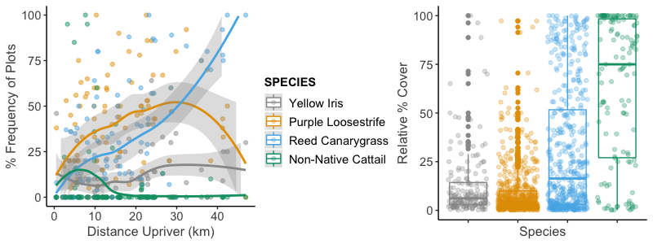

Figure 9. Scatterplot showing the percent frequency of plots of four known invasive species in the Fraser Estuary with increasing distance upriver (left) and the relative percent cover of those species, when present in a plot (right). Data were collected from created and reference marshes in the FRE by Lievesley et al. (2016) and in 2021. Loess regression lines display non-parametric trends in the scatterplot data.

Invasive species that can defy these trends and successfully establish in the delta front should be of concern to managers, as they may be able to exploit the low competitive ability of sympatric natives. In the FRE, invasive plants that are most successful along the delta front are English cordgrass (*Spartina anglica*), which is not present in any of the sites included in this study, and non-native cattail, which differs from the other estuarine invasive plants in being primarily restricted to the lower 10 km of the estuary, and was observed incidentally or in sample plots in only 17 (22%) of created tidal marsh sites (Stewart, 2021). Conversely, yellow flag iris, purple loosestrife, and reed canarygrass were found in 48 (62%), 73 (94%) and 65 (83%) sites, respectively. Though native dominance was found to be highest near the estuary mouth, cattail-invaded sites were often outliers, with low native dominance. This may be attributed to the high displacement ability of cattail and the low competitive ability of sympatric species, as plots containing cattail averaged a relative percent cover of 68.8 (SD = 37.2%), significantly higher than any other invasive species (Fig. 9).

This trend of declining native dominance with distance upriver may be useful for managers and practitioners as they plan for invasive species in the design and maintenance of created tidal marshes. Sites constructed further upriver may require more intensive and long-term invasive species management, as they appear more vulnerable to invasion. Near the estuary mouth, managers may need to shift their attention towards non-native cattail. Stewart (2021) found that created tidal marshes in the FRE were more proportionally invaded and vulnerable to invasion than natural marshes, and suggested that design, including factors such as elevation, proximity to neighbouring infestations, and connectivity to the Fraser River can mitigate the prospect for invasion. Our findings support the role of design in mitigating invasion, as of the 17 created marshes where cattail is present, 9 (60%) are closed embayments, representing 75% of all such sites in this study. The susceptibility of closed embayments to invasive cattail is likely due to a combination of abundant propagule sources in the vicinity and poor drainage (Stewart 2021). These marshes are contained within basins with outlets to neighbouring distributary channels. These outlets are frequently armored with rock aprons, which are used to stabilize outlet elevations and prevent head cutting, and debris fences which are designed to mitigate woody debris capture and retention. Poor site drainage results, and saturation stress likely supplants tidal inundation as the primary stressor within these basins, promoting the dominance of cattail (M. Adams, personal communication, January 2022).

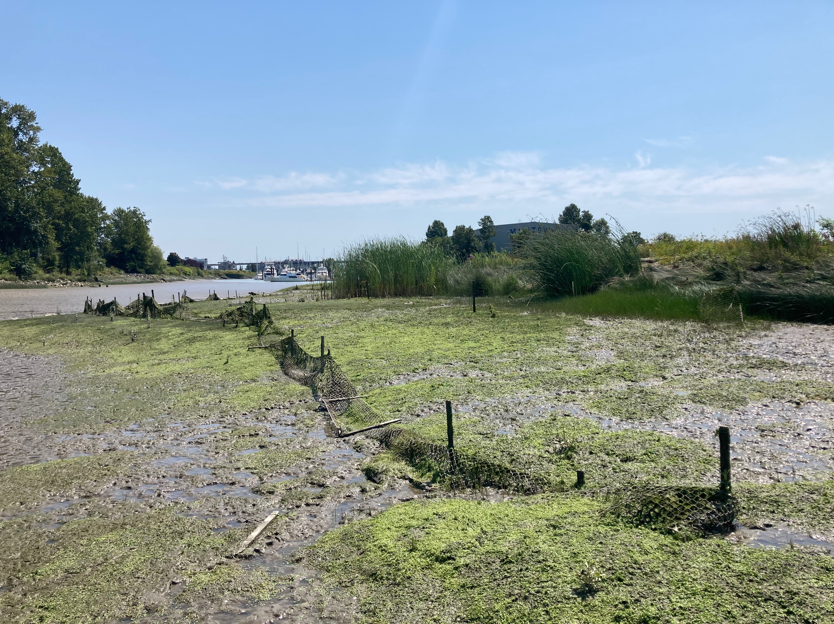

***Case Study: Eburne Slough***

Although the design and implementation of tidal marsh creation projects has improved over time, stressors continue to threaten modern project outcomes in the FRE. This tidal marsh creation project was completed in 2013, and included a planted band of Lyngbye’s sedge around the marsh perimeter with Baltic rush in higher elevations. In July 2021 we observed very little Lyngbye’s sedge, and large areas that were planted with sedge had transitioned to bare mud or were colonized by small, mudflat-associated specialists. Invasive cattail had also established in the mudflat zone. Grazing was likely the driver of these losses, and exclosure fencing is currently degraded and no longer functioning.

## Monitoring Implications

Contrary to our expectations, created marsh age did not have a significant effect on the quantity of recession, nor on the relative percent cover of native species. This finding suggests that well-designed and implemented projects that can mitigate threats such as invasive species, erosion, and goose herbivory, particularly in the early years while they are establishing, are more likely to be resilient in the long term (inset right). This also suggests that the general trajectory of a project may be evident not long after completion, however not without caveats. Intermittent long-term monitoring is still essential, as several reports have documented stochastic events, deteriorating infrastructure (e.g., shear booms, debris fences), and other unpredictable issues such as novel species invasions that require follow-up actions after the determined monitoring period[4] (Kistritz 1995; Adams & Williams 2004; Lievesley et al. 2016). Site age was not included in our richness models, as we included data from natural marshes that had no defined age. However, our reference site variable operated as a proxy for age to a degree, as reference sites are inherently older than created sites. Since the placement of a plot in a reference site had no observable effect on richness in our model, it appears that created marshes can resemble natural marshes in their species composition and vegetation health within a few decades, either through dispersal from upstream habitats (Nilsson et al. 1994), or through propagules introduced via transplant plugs from neighbouring donor marshes.

## Site Design Trade-offs

These findings have shed light on factors that play into the health of created marshes in the FRE, but they by no means provide a simple formula to ensure their success. In part this is due to the dynamic and unpredictable nature of the system, but also the complexity of building and sustaining sites that are resilient to numerous stressors simultaneously. This study has discussed a subset of these stressors (i.e., grazing, wave erosion, sea-level rise, invasive species) and there are numerous others that were not explored (e.g., log debris, geofluvial processes, pollution). The challenge for those designing, implementing, and managing these marshes is that mitigation strategies often differ and or even conflict among stressors, and therefore design trade-offs regularly occur (Table 1).

Table 1. Examples of potential pros and cons of various created tidal marsh design elements

|  |  |  |
| --- | --- | --- |
| **Design Element** | **Pros** | **Cons** |
| Closed embayment design | * often inaccessible for Canada Geese * protected from erosional processes * log debris can be managed through debris fence structures at embayment entrance | * prone to dominance by invasive species due , particularly cattail, and lower species richness * dependent on available terrestrial habitat, which is not common in the FRE * potentially less resilient to SLR due to inhibited sediment delivery processes and poor drainage (Coleman et al. 2020) * prone to log debris entrapment if debris fences are not installed |
| Marsh bench design | * comparable plant diversity to reference marshes * potentially more resilient to SLR due to connectivity with channel sediment supply (dependent on erosion) | * susceptible to erosion from riverine processes and boat wake * vulnerable to geese herbivory * vulnerable to log debris accumulation and disturbance, which may promote colonization of invasive species |
| Low elevation design | * conditions are less suitable for invasive establishment (particularly in brackish tidal marshes) * log debris is unlikely to accumulate for prolonged periods (Thomas 2002) * more fish access, inundated for longer periods of tidal cycle | * potentially more susceptible to marsh recession due to elevated plant stress * potentially more vulnerable to effects of SLR, dependent on accretion * lower plant community diversity (particularly in brackish marshes) |
| Upper estuary location | * less influenced by the effects of SLR * high plant community diversity * marsh habitat more deficient in vicinity due to diking and industry | * more susceptible to dominance by invasive species, particularly reed canarygrass * more vulnerable to recession, perhaps due to elevated grazing pressure or erosion |
| North arm location | * marsh habitat more deficient in vicinity due to diking and industry | * more vulnerable to recession, perhaps due to elevated grazing pressure, sediment supply, or erosion |

## Data Limitations, Caveats, & Future Research

While these findings and interpretations provide insights for managers and practitioners in the FRE, there are key data limitations and caveats to consider. Apart from one site (00-001), all the sites sampled in this study were riverine tidal marshes that were upstream of the estuary leading edge, where tidal marsh habitat is most abundant. This was largely determined by the distribution of created tidal marshes, and the need for comparable reference sites. The applicability of these findings to future projects at the leading edge of the estuary is therefore uncertain, as data from these environments were not incorporated into our models, though certain trends (e.g., increasing richness and invasive dominance with distance upriver) and discussed stressors (e.g., grazing, threat of invasive cattail) likely still apply in many cases. Similarly, the tidal marsh creation projects visited in this study averaged 3200.2 m2 (SD = 7600.1) in size, with only three projects exceeding 20,000 m2 (2 ha). As a result, the applicability of these findings to large projects may also be imperfect, as few examples currently exist in the FRE.

The variables included in these models point to important trends in marsh recession and vegetation resilience, but we did not elucidate the mechanisms underlying these phenomena. Further investigation will be required to identify the true effects of these mechanisms, and to determine how best to mitigate them. Our findings indicate that protective structures, and sites that are isolated from erosional processes (i.e., embayments, sloughs) may reduce marsh recession, but further study should investigate the direct effects of wake erosion on marsh health, and the most reliable and cost-effective techniques to mitigate these impacts. Likewise, further research is needed to identify the distribution and magnitude of Canada Goose herbivory impacts and to develop effective regional goose management strategies that go beyond short-term, localized mitigation.

We also acknowledge that within the context of an urban estuary, many of the stressors discussed in this paper are not confined to created tidal marshes. In the case of the richness and exploratory versions of the relative % cover native models, we were able to incorporate reference site data and a reference site variable into our models for comparative purposes. This was not the case in our recession model, as investigating and quantifying recession in natural marshes was outside the scope of this study. We were therefore unable to evaluate whether the recession we observed was an issue unique to created tidal marshes, suggesting their compromised resilience, or whether this is reflective of a larger recession issue occurring throughout the estuary (Kistritz et al. 1992). Future research should aim to identify changes in natural marsh foreshores of the FRE, to shed light on the estuary-wide impacts of these stressors.

None of our models exceeded *R*2 = 0.501, thus indicating there are likely important biotic and abiotic explanatory variables that were not included as covariates, but which could have improved model performance and further accounted for variation in our data. Examples of such abiotic factors include true measures of salinity and tidal prism (i.e., not inferred from distance upriver), direct measurements of wave energy impacting the created marshes, more accurate plot elevations using RTK units, and site-level edaphic data to ascertain soil qualities. Design and implementation factors also suffered from data deficiency and incomplete records. Ideally, project design factors like planting prescriptions, geese mitigation, monitoring plans, and maintenance plans would have been included as variables, as well as overall project cost. Our models provide useful insights, but these should be seen as steppingstones to further and more detailed investigations.

# Conclusion

We sought to identify factors that influence the persistence of created tidal marshes in the FRE through field sampling, spatial analysis, and statistical models. Marsh recession was observed in 40 out of the 78 created tidal marshes visited, equating to approximately 9.3%, or 23,676 m2 of the 255,541 m2 of created habitat surveyed. We found that increases in mean site elevation had a negative effect on recession, while recession was higher in sites that were further upriver and located in the North Arm. Though inconclusive, there are indications that protective design elements, such as shear booms, embayed designs, and offshore structures may mitigate marsh recession. We suggest that boat wake and herbivory by invasive Canada Geese may be contributing factors to these losses, and require further investigation. Dominance by native species was found to decrease with distance upriver and was lower on average in closed embayments than other marsh designs. Project age had no significant effect on recession, nor dominance of native species, suggesting that well-designed projects that are allowed to establish through mitigative measures are likely to persist in the long term, though long-term monitoring is still recommended to account for unforeseen events. Native and non-native richness showed comparable trends in both reference and created tidal marshes, generally increasing with elevation and distance upriver. Plots located in reference sites showed no significant difference in native richness from those of created tidal marshes, suggesting plant communities of created marshes can compositionally resemble those of natural marshes within decades, likely due to natural colonization or propagules within donor plugs. We hope that lessons from these investigations will advance the knowledge of tidal marsh creation in the region, inform future management, and inspire further research in the Fraser Estuary.

# Data Availability Statement

The data, R Scripts, and other digitized materials related used in this study are openly available on Github at <https://github.com/asarum-ecological/FRE_CreatedTidalMarshes_2022>. The authors request that appropriate credit be given should these materials be used for further study. We recommend (Lievesley et al. 2016) be cited for 2015 data, and this report be cited for 2021 data.

# Works Cited

Adams MA. 1993. Purple loosestrife in the Fraser River Estuary. Technical Report H-93-01. Fraser River Estuary Management Program Office, New Westminster, B.C.

Adams MA, Williams GL. 2004. Tidal marshes of the Fraser River estuary: composition, structure, and a history of marsh creation efforts to 1997. Pages 147–172 in Groulx DC, Luternauer JL, Bilderback DE, editors. Fraser River Delta, British Columbia: Issues of an Urban Estuary.

Allan E, Weisser W, Weigelt A, Roscher C, Fischer M, Hillebrand H. 2011. More diverse plant communities have higher functioning over time due to turnover in complementary dominant species. Proceedings of the National Academy of Sciences **108**:17034–17039.

Alldred M, Baines SB. 2016. Effects of wetland plants on denitrification rates: a meta-analysis. Ecological Applications **26**:676–685.

Arias-Ortiz A, Oikawa PY, Carlin J, Masqué P, Shahan J, Kanneg S, Paytan A, Baldocchi DD. 2021. Tidal and Nontidal Marsh Restoration: A Trade-Off Between Carbon Sequestration, Methane Emissions, and Soil Accretion. Journal of Geophysical Research: Biogeosciences **126**:e2021JG006573.

Avenza Systems Inc. 2021. Avenza Maps. Toronto, Ontario.

Balke E. 2017. Investigating the role of elevated salinity in the recession of a large brackish marsh in the Fraser River Estuary. Pages 1–108. Master’s Project. Simon Fraser University & British Columbia Institute of Technology, Burnaby.

Barbier EB, Hacker SD, Kennedy C, Koch EW, Stier AC, Silliman BR. 2011. The value of estuarine and coastal ecosystem services. Ecological Monographs **81**:169–193.

Bartoń K. 2020. MuMIn: Multi-Model Inference. Available from https://CRAN.R-project.org/package=MuMIn.

Bates D, Mächler M, Bolker B, Walker S. 2015. Fitting Linear Mixed-Effects Models Using **lme4**. Journal of Statistical Software **67**. Available from http://www.jstatsoft.org/v67/i01/ (accessed September 7, 2021).

Bilkovic DM, Mitchell M, Davis J, Andrews E, King A, Mason P, Herman J, Tahvildari N, Davis J. 2017. Review of boat wake wave impacts on shoreline erosion and potential solutions for the Chesapeake Bay. Pages 1–68. STAC Publication 17-002. Edgewater, MD.

Bilkovic DM, Mitchell MM, Davis J, Herman J, Andrews E, King A, Mason P, Tahvildari N, Davis J, Dixon RL. 2019. Defining boat wake impacts on shoreline stability toward management and policy solutions. Ocean & Coastal Management **182**:104945.

Borde AB, Diefenderfer HL, Cullinan VI, Zimmerman SA, Thom RM. 2020. Ecohydrology of wetland plant communities along an estuarine to tidal river gradient. Ecosphere **11**:e03185.

Boyd S. 1979. A review of various tidal marsh development techniques. Information Report No.1. Westwater Research Centre, University of British Columbia, Vancouver, B.C.

Boyle CA. 1997. Changes in land cover and subsequent effects on Lower Fraser Basin ecosystems from 1827 to 1990. Environmental Management **21**:185–196.

Bradfield GE, Porter GL. 1982. Vegetation structure and diversity components of a Fraser estuary tidal marsh. Canadian Journal of Botany **60**:440–451.

Bradford MJ, Macdonald JS, Levings CD. 2017. Monitoring fish habitat compensation in the Pacific region: lessons from the past 30 years. Page vi + 26. 2017/033, DFO Can. Sci. Advis. Sec. Res. Doc. Fisheries and Oceans Canada, Ottawa.

Broome SW, Craft CB, Burchell MR. 2019. Tidal marsh creation. Pages 789–816 in Perillo GME, Wolanski E, Cahoon DR, Hopkinson CS, editors. Coastal wetlands: an integrated ecosystem approach2nd edition. Elsevier, Amsterdam.

Brophy LS, Greene CM, Hare VC, Holycross B, Lanier A, Heady WN, O’Connor K, Imaki H, Haddad T, Dana R. 2019. Insights into estuary habitat loss in the western United States using a new method for mapping maximum extent of tidal wetlands. PLOS ONE **14**:e0218558.

Butler RW, Campbell RW. 1987. The birds of the Fraser River Delta: populations, ecology and international significance. Occasional Paper **65**:1–73.

Chalifour L, Scott DC, MacDuffee M, Iacarella JC, Martin TG, Baum JK. 2019. Habitat use by juvenile salmon, other migratory fish, and resident fish species underscores the importance of estuarine habitat mosaics. Marine Ecology Progress Series **625**:145–162.

Chalifour L, Scott DC, MacDuffee M, Stark S, Dower JF, Beacham TD, Martin TG, Baum JK. 2021. Chinook salmon exhibit long-term rearing and early marine growth in the Fraser River, British Columbia, a large urban estuary. Canadian Journal of Fisheries and Aquatic Sciences **78**:539–550.

Coleman DJ, Ganju NK, Kirwan ML. 2020. Sediment delivery to a tidal marsh platform is minimized by source decoupling and flux convergence. Journal of Geophysical Research: Earth Surface **125**. Available from https://onlinelibrary.wiley.com/doi/10.1029/2020JF005558.

Community Mapping Network (CMN). 2021. BIEAP - FREMP Atlas. Available from https://cmnmaps.ca/dfo_fremp/.

Coops H, Geilen N, Verheij HJ, Boeters R, van der Velde G. 1996a. Interactions between waves, bank erosion and emergent vegetation: an experimental study in a wave tank. Aquatic Botany **53**:187–198.

Coops H, van den Brink FWB, van der Velde G. 1996b. Growth and morphological responses of four helophyte species in an experimental water-depth gradient. Aquatic Botany **54**:11–24.

Correa RE, Xiao K, Conrad SR, Wadnerkar PD, Wilson AM, Sanders CJ, Santos IR. 2021. Groundwater Carbon Exports Exceed Sediment Carbon Burial in a Salt Marsh. Estuaries and CoastsDOI: 10.1007/s12237-021-01021-1. Available from https://link.springer.com/10.1007/s12237-021-01021-1.

Crain CM, Silliman BR, Bertness SL, Bertness MD. 2004. Physical and biotic drivers of plant distribution across estuarine salinity gradients. Ecology **85**:2539–2549.

Crandell CJ. 2001. Effect of grazing by *Branta canadensis* (Canada Geese) on the fitness of *Carex lyngbyei* (Lyngby’s sedge) at a restored wetland in the Duwamish River Estuary. Master’s Thesis. University of Washington, Seattle, WA.

Cronk JK, Fennessy MS. 2001. Wetland plants: biology and ecology. Lewis Publishers, Boca Raton, Fla.

Dahl TE. 1990. Wetlands: losses in the United States 1780s to 1980s. Pages 1–14. U.S. Department of the Interior, Fish and Wildlife Research. Available from https://www.fws.gov/wetlands/documents/Wetlands-Losses-in-the-United-States-1780s-to-1980s.pdf.

Dawe NK, Boyd WS, Martin T, Anderson S, Wright M. 2015. Significant marsh primary production is being lost from the Campbell River estuary: another case of too many resident Canada Geese (*Branta canadensis*)? **25**:11.

Department of Fisheries and Oceans. 1986. Policy for the management of fish habitat. Pages 1–32. Communications Directorate, Ottawa, Ontario.

Dorcey HJ. 2004. Evolution of estuarine governance in a metropolitan region: collaborating for sustainability in the Fraser River estuary. Pages 247–262 in Groulx DC, Luternauer JL, Bilderback DE, editors. Fraser River Delta, British Columbia: Issues of an Urban Estuary.

El Safty H, Marsooli R. 2020. Ship wakes and their potential impacts on salt marshes in Jamaica Bay, New York. Journal of Marine Science and Engineering **8**:325.

Engels JG, Jensen K. 2009. Patterns of wetland plant diversity along estuarine stress gradients of the Elbe (Germany) and Connecticut (USA) Rivers. Plant Ecology & Diversity **2**:301–311.

Fisheries and Oceans Canada (DFO). 2019. Fish and Fish Habitat Protection Policy Statement. Page 37. Ottawa.

Fitzpatrick SM, Rick TC, Erlandson JM. 2015. Recent Progress, Trends, and Developments in Island and Coastal Archaeology. The Journal of Island and Coastal Archaeology **10**:3–27.

Forysinski K. 2019. Nature-based flood protection: the contribution of tidal marsh vegetation to wave attenuation at Sturgeon Bank. Master’s Thesis. University of British Columbia, Vancouver, B.C.

Fox J, Weisberg S. 2019. An {R} Companion to Applied RegressionThird Edition. Sage, Thousand Oaks, California. Available from URL: https://socialsciences.mcmaster.ca/jfox/Books/Companion/.

Genua L, Start D, Gilbert B. 2017. Fragment size affects plant herbivory via predator loss. Oikos **126**:1357–1365.

Glamore WC. 2008. A decision support tool for assessing the impact of boat wake waves on inland waterways. Pages 1–20.

GRASS Development Team. 2012. Geographic Resources Analysis Support System (GRASS). Open Source Geospatial Foundation. Available from http://grass.osgeo.org.

Grout JA, Levings CD, Richardson JS. 1997. Decomposition Rates of Purple Loosestrife (*Lythrum salicaria*) and Lyngbyei’s Sedge (*Carex lyngbyei*) in the Fraser River Estuary. Estuaries **20**:96–102.

Haines EB, Hanson RB. 1979. Experimental degradation of detritus made from the salt marsh plants *Spartina alterniflora* Loisel., *Salicornia virginica* L., and *Juncus roemerianus* Scheele. Journal of Experimental Marine Biology and Ecology **40**:27–40.

Hood WG. 2020. Applying tidal landform scaling to habitat restoration planning, design, and monitoring. Estuarine, Coastal and Shelf Science **244**:106060.

Hoos LM, Packman GA. 1974. The Fraser River Estuary: status of environmental knowledge to 1974. Report of the Estuary Working Group, Department of the Environment, Regional Board Pacific Region. Environment Canada, Ottawa.

Houser C. 2010. Relative Importance of Vessel-Generated and Wind Waves to Salt Marsh Erosion in a Restricted Fetch Environment. Journal of Coastal Research **26**:230–240. Coastal Education & Research Foundation, Inc.

James G, Witten D, Hastie T, Tibshirani R, editors. 2013. An introduction to statistical learning: with applications in R. Springer, New York.

James-Pirri M-J, Roman CT, Heltshe JF. 2007. Power analysis to determine sample size for monitoring vegetation change in salt marsh habitats. Wetlands Ecology and Management **15**:335–345.

Jenkins NJ, Yeakley JA, Stewart EM. 2008. First-year responses to managed flooding of lower Columbia River bottomland vegetation dominated by *Phalaris arundinacea*. Wetlands **28**:1018–1027.

Jessop J, Spyreas G, Pociask GE, Benson TJ, Ward MP, Kent AD, Matthews JW. 2015. Tradeoffs among ecosystem services in restored wetlands. Biological Conservation **191**:341–348.

Johnson OF, Lishawa SC, Lawrence BA. 2019. Submerged harvest reduces invasive *Typha* and increases soil macronutrient availability. Plant and Soil **442**:157–167.

Kehoe LJ et al. 2021. Conservation in heavily urbanized biodiverse regions requires urgent management action and attention to governance. Conservation Science and Practice **3**. Available from https://onlinelibrary.wiley.com/doi/10.1111/csp2.310 (accessed September 13, 2021).

Kennish MJ. 2002. Environmental threats and environmental future of estuaries. Environmental Conservation **29**:78–107.

Kentula ME. 2000. Perspectives on setting success criteria for wetland restoration. Ecological Engineering **15**:199–209.

Kercher SM, Zedler JB. 2004. Flood tolerance in wetland angiosperms: a comparison of invasive and noninvasive species. Aquatic Botany **80**:89–102.

Kistritz R, Williams G, Scott J. 1992. Inspection of red-coded habitat: Fraser River Estuary summer of 1992. Pages 1–177. Fraser River Estuary Management Program, New Westminster, B.C.

Kistritz RU. 1995. Habitat compensation, restoration and creation in the Fraser River Estuary: are we achieving a no-net-loss of fish habitat? Pages 1–113. Can. Tech. Rept. 2349, Fish. Aquat. Sci.

Klimešová J. 1994. The effects of timing and duration of floods on growth of young plants of *Phalaris arundinacea* L. and *Urtica dioica* L.: an experimental study. Aquatic Botany **48**:21–29.

Kondoh M. 2003. Habitat fragmentation resulting in overgrazing by herbivores. Journal of Theoretical Biology **225**:453–460.

Larkin DJ, Madon SP, West JM, Zedler JB. 2008. Topographic heterogeneity influences fish use of an experimentally restored tidal marsh. Ecological Applications **18**:483–496. Ecological Society of America.

Lee JJ. 2021. The impacts of exotic *Typha* on benthic invertebrate communities in the South Arm of the Fraser River Estuary. Pages 1–33. Master’s Project. Simon Fraser University & British Columbia Institute of Technology, Burnaby.

Levings CD. 2000. An overview assessment of compensation and mitigation techniques used to assist fish habitat management in British Columbia estuaries. Pages 341–347 in Knudsen EE, Steward CR, MacDonald DD, Williams JE, Reiser DW, editors. Sustainable Fisheries Management1st Edition. CRC Press, Boca Raton.

Levings CD. 2004a. Knowledge of fish ecology and its application to habitat management. Pages 213–236 in Groulx DC, Luternauer JL, Bilderback DE, editors. Fraser River Delta, British Columbia: Issues of an Urban Estuary.

Levings CD. 2004b. Two decades of fish habitat restoration and bioengineering on the Fraser River Estuary, British Columbia, Canada. Pages 164–168 Oceans ’04 MTS/IEEE Techno-Ocean ’04 (IEEE Cat. No.04CH37600). IEEE, Kobe, Japan. Available from http://ieeexplore.ieee.org/document/1402912/ (accessed September 7, 2021).

Levings CD, Nishimura [ed.] DJH. 1996. Created and restored sedge marshes in the lower Fraser River and estuary: An evaluation of their functioning as fish habitat. Pages 1–143. Canadian Technical Report 2126, Fisheries and Aquatic Sciences.

Levy DA, Northcote TG. 1982. Juvenile Salmon Residency in a Marsh Area of the Fraser River Estuary. Canadian Journal of Fisheries and Aquatic Sciences **39**:270–276.

Lievesley M, Stewart D, Knight R, Mason B. 2016. Assessing habitat compensation and examining limitations to native plant establishment in the lower Fraser River Estuary. Pages 1–63. Available from https://www.cmnbc.ca/wp-content/uploads/2018/11/Assessing-Habitat-Compensation_2016Appendix-I-IV.pdf.

Loreau M, de Mazancourt C. 2013. Biodiversity and ecosystem stability: a synthesis of underlying mechanisms. Ecology Letters **16**:106–115.

Marijnissen R, Stefan A. 2017. Marsh recession and erosion study of the Fraser Delta, B.C., Canada from historic satellite imagery. Communications on Hydraulic and Geotechnical Engineering **2017–1**:59.

Miller RC, Zedler JB. 2003. Responses of native and invasive wetland plants to hydroperiod and water depth. Plant Ecology **167**:57–69.

Naeem S. 1998. Species redundancy and ecosystem reliability. Conservation Biology **12**:39–45.

Nakagawa S, Schielzeth H. 2013. A general and simple method for obtaining *R* 2 from generalized linear mixed-effects models. Methods in Ecology and Evolution **4**:133–142.

Nanson GC, Krusenstierna AV, Bryant EA. 1994. Experimental measurements of river-bank erosion caused by boat-generated waves on the Gordon River, Tasmania. Regulated Rivers: Research & Management **9**:1–14.

Nilsson C, Ekblad A, Dynesius M, Backe S, Gardfjell M, Carlberg B, Hellqviist S, Jansson R. 1994. A comparison of species richness and traits of riparian plants between a main river channel and its tributaries. Journal of Ecology **82**:281–295. [Wiley, British Ecological Society].

O’Meara TA, Hillman JR, Thrush SF. 2017. Rising tides, cumulative impacts and cascading changes to estuarine ecosystem functions. Scientific Reports **7**:10218.

Peterson CH, Able KW, DeJong CF, Piehler MF, Simenstad CA, Zedler JB. 2008. Practical proxies for tidal marsh ecosystem services. Pages 221–266 Advances in Marine Biology. Elsevier. Available from https://linkinghub.elsevier.com/retrieve/pii/S0065288108000047.

Pontee N. 2013. Defining coastal squeeze: A discussion. Ocean & Coastal Management **84**:204–207.

QGIS Development Team. 2021. QGIS Geographic Information System. QGIS Geographic Information System.

R Core Team. 2021. R: A language and environment for statistical computing. R Foundation for Statistical Computing, Vienna, Austria. Available from https://www.R-project.org/.

Small C, Nichols RJ. 2003. A global analysis of human settlement in coastal zones. Journal of Coastal Research **19**:17.

Stewart D. 2021. Undetected but widespread: the cryptic invasion of non-native cattail (*Typha*) in the Fraser River Estuary. Master’s Thesis. University of British Columbia, Vancouver. Available from https://open.library.ubc.ca/soa/cIRcle/collections/ubctheses/24/items/1.0397016.

Sutherland TF, Elner RW, O’Neill JD. 2013. Roberts Bank: Ecological crucible of the Fraser River estuary. Progress in Oceanography **115**:171–180.

Thomas P. 2002. Wood debris removal from British Columbia’s lower Fraser River marshes: an analysis of a complex restoration issue. Pages 1–37.

Tilman D. 1997. Community invasibility, recruitment, limitation, and grassland biodiversity. Ecology **78**:81–92.

Vitousek PM, Aber JD, Howarth RW, Likens GE, Matson PA, Schindler DW, Schlesinger WH, Tilman DG. 1997. Human alteration of the global nitrogen cycle: sources and consequences. Ecological Applications **7**:737–750.

Zedler JB, Callaway JC. 2000. Evaluating the progress of engineered tidal wetlands. Ecological Engineering **15**:211–225.

Zedler JB, Kercher S. 2004. Causes and consequences of invasive plants in wetlands: opportunities, opportunists, and outcomes. Critical Reviews in Plant Sciences **23**:431–452.

# Appendix

## Appendix A: Reference Marsh Descriptions

Table 2. Descriptive information of reference sites included in this study.

|  |  |  |  |  |  |  |
| --- | --- | --- | --- | --- | --- | --- |
| **ID** | **Year Sampled** | **UTM** | **General Location** | **Elevation (m)**  **(min, max, avg., stdev)** | **Saltwater Influenced** | **Site Description** |
| REF-03 | 2021 | 10 U 517665 5452318 | Confluence of Pitt River and Fraser Main Arm, Pitt Meadows | 0.74, 2.18, 1.57, 0.18 | no | Exposed marsh bench located across the channel from Douglas Island near the Pitt/Fraser confluence. Pilings are present, but log storage has been minimal in adjacent channel in recent decades. Foreshore varies from steep cutbank to gradual transition to mudflat. |
| REF-04 | 2021 | 10 U 515483 5452122 | NW corner of Douglas Island, Fraser Main Arm | 0.45, 2.19, 1.40, 0.26 | no | Exposed marsh bench located on the NW corner of Douglas Island (managed by Metro Vancouver Regional District). Pilings are present, but log storage has been minimal in adjacent channel in recent decades. Foreshore is a gradual slope into the subtidal. |
| REF-05 | 2021 | 10 U 508902 5452128 | NE corner of Sapperton Bar, Fraser Main Arm | 0.49, 1.71, 1.33, 0.23 | no | Exposed marsh on a recently vegetated sandbar (~20 years vegetated). The marsh accreted and colonised naturally, likely due to reduced water flow from extensive log storage in the vicinity. Site is protected by log storage for most of the year. |
| REF-07 | 2021 | 10 U 502812 5446405 | South bank of Annacis Channel, Annacis Island | 0.06, 1.71, 1.10, 0.26 | yes | Exposed marsh bench with undulating topography, including a backshore channel that flows to the southwest. The site is protected by log storage booms for much of the year. Foreshore varies from small cutbank to gradual slope. |
| REF-09 | 2021 | 10 U 498779 5443907 | Northern edge of Tilbury Island, Fraser Main Arm | -0.03, 2.58, 1.14, 0.39 | yes | Embayed marsh enclosed by natural (?) sand berm to the north. No log pilings or foreshore protection present. Foreshore is gradually sloped. |
| REF-11 | 2021 | 10 U 494275 5440327 | SW corner of Deas Island, Deas Slough | -0.61, 1.76, 0.78, 0.54 | yes | Marsh bench with gradual foreshore slope. Site is protected from erosional forces of the Fraser Main Arm but is exposed to regular recreational boat activity from neighbouring marina. |
| REF-13 | 2021 | 10 U 490916 5436888 | East bank of Canoe Pass, Port Guichon, Delta | -0.23, 2.13, 1.36, 0.40 | yes | Exposed marsh bench with gradual foreshore slope. The site is exposed and unprotected, but occurs in Canoe Pass, where boat traffic and erosional river flows are minor. |
| REF-14 | 2021 | 10 U 488838 5440112 | North bank of South Arm, Lulu Island | -0.74, 2.15, 0.86, 0.36 | yes | Marsh bench located immediately upstream of Shady Island. Site may be somewhat protected by debris deflection boom located immediately south. Foreshore is a gradual slope. |
| REF-17 | 2021 | 10 U 486897 5447333 | North bank of Middle Arm, Sea Island | -0.78, 3.41, 1.31, 0.59 | yes | Marsh bench located immediately upstream of Swishwash Island. Site is unprotected from wake and river erosion, but erosional forces are likely minor in the Middle Arm. Foreshore is a gradual slope into the subtidal. |
| REF-02-2015 | 2015 | 10 U 494560 5449859 | South bank of North Arm, Lulu Island | 0.74, 2.18, 1.57, 0.18 | yes | Marsh bench located on the north shore of Lulu Island, across from the eastern edge of Mitchell Island. Foreshore is primarily a cutbank with intertidal mudflat below. Site is regularly protected by log storage booms. |
| REF-03-2015 | 2015 | 10 U 488544 5450610 | South bank of North Arm, Sea Island | 0.74, 2.18, 1.57, 0.18 | yes | Marsh bench located upstream of McDonald Beach Park, Sea Island. Foreshore is a cutbank, with intertidal mudflat below. Barges are occasionally moored immediately downstream, but site is generally unprotected from wave and current erosion. |
| REF-05-2015 | 2015 | 10 U 489567 5448239 | North bank of Middle Arm, Sea Island | -0.22, 2.96, 0.79, 0.35 | yes | Slightly embayed marsh located immediately downstream of Moray Bridge. Foreshore is a gradual transition to mudflat. Two major drainage channels bisect the site. |
| REF-09-2015 | 2015 | 10 U 493041 5437700 | SW corner of Ladner Marsh, South Arm | -0.03, 2.58, 1.14, 0.39 | yes | Exposed marsh bench with a gradually sloped foreshore. Located near entrance to Ladner Slough. Site is not protected but is isolated from the wake and current erosion of the Main Arm. Within the South Arm Marshes Wildlife Management Area. |
| REF-10-2015 | 2015 | 10 U 496782 5442394 | SW corner of Tilbury Island, South Arm | -0.38, 2.06, 1.04, 0.28 | yes | Unprotected marsh bench located on SW Tilbury Island near the entrance to Tilbury Slough. Foreshore is a gradual transition to intertidal mudflat. |
| REF-11-2015 | 2015 | 10 U 504826 5447809 | South bank of Annacis Channel, Annacis Island | 0.31, 3.00, 1.04, 0.28 | yes | Site is located immediately downstream of Derwent Way Bridge. Foreshore is a gradual transition to intertidal mudflat. Site is not protected from wave/current erosion, but Annacis Channel experiences less wake/erosion than major channels. |
| REF-12-2015 | 2015 | 10 U 501934 5445270 | SW corner of Annacis Island, Fraser Main Arm | -0.19, 1.93, 1.13 ,0.19 | yes | Exposed marsh bench with a combination of cutbank and gradually sloped foreshore. Site is intermittently protected from wave erosion by moored barges. No major channels present. |

## Appendix B. Species List from 2015 and 2021 Vegetation Surveys

Table 3. List of macrophytes observed in plots during 2015 and 2021 vegetation surveys with accompanying origin status (N = Native, E = Exotic, I = Invasive). For cryptic species where origin could not be determined, origin status is ‘U’. Non-native species were classified as invasive if in our judgement they demonstrate the ability to outcompete and displace native plant communities in tidal marsh habitats.

|  |  |  |  |  |
| --- | --- | --- | --- | --- |
| **Species** | **Common Name** | **Origin** | **2015** | **2021** |
| *Achillea millefolium* | yarrow | N |  | X |
| *Acorus americanus* | American sweetflag | N |  | X |
| *Agrostis capillaris* | colonial bentgrass | E | X | X |
| *Agrostis gigantea* | redtop | E | X | X |
| *Agrostis stolonifera* | creeping bentgrass | E | X | X |
| *Ajuga sp.* | unidentified ajuga | E | X |  |
| *Alisma lanceolatum* | lance-leaf water-plantain | E |  | X |
| *Alisma triviale* | water plantain | N |  | X |
| *Alisma sp.* | unidentified water plantain | U | X |  |
| *Artemesia vulgaris* | mugwort | E | X |  |
| *Athyrium filix-femina* | lady fern | N | X | X |
| *Betula pendula* | European birch | E |  | X |
| *Bidens cernua* | nodding beggarticks | N | X | X |
| *Bidens connata* | purplestem beggarticks | E | X |  |
| *Bidens tripartita* | three-parted beggarticks | E | X |  |
| *Calamagrostis canadensis* | bluejoint | N | X | X |
| *Callitriche heterophylla* | diverse-leaved water-starwort | N | X |  |
| *Callitriche hermaphroditica* | northern starwort | N | X |  |
| *Callitriche stagnalis* | water starwort | E | X | X |
| *Caltha palustris* | marsh marigold | N | X | X |
| *Calystegia sepium* | morning-glory | E |  | X |
| *Cardamine oligosperma* | little western bitter-cress | N | X |  |
| *Cardamine sp.* | bitter-cress | U | X | X |
| *Carex aquatilis var. dives* | Sitka sedge | N | X | X |
| *Carex cusickii* | Cusick's sedge | N | X | X |
| *Carex lyngbyei* | Lyngbye's sedge | N | X | X |
| *Carex obnupta* | slough sedge | N | X | X |
| *Carex scoparia* | pointed broom sedge | N | X |  |
| *Carex stipata* | prickly sedge | N | X | X |
| *Carex utriculata* | beaked sedge | N | X | X |
| *Ceratophyllum echinatum* | hornwort | N | X |  |
| *Chenopodium album* | lamb's quarters | E | X |  |
| *Clematis vitalba* | traveler's joy | E | X |  |
| *Cicuta douglasii* | western water hemlock | N | X | X |
| *Cirsium arvense* | Canada thistle | E | X | X |
| *Comarum palustre* | marsh cinquefoil | N | X | X |
| *Conzya canadensis* | horseweed | N | X |  |
| *Cotula coronopifolia* | brass buttons | E |  | X |
| *Crassula aquatica* | pigmy-weed | N | X | X |
| *Crepis tectorum* | annual hawksbeard | E | X |  |
| *Dactylis glomerata* | orchard-grass | E | X |  |
| *Daucus carota* | wild carrot | E | X |  |
| *Deschampsia cespitosa ssp. bringensis* | tufted hairgrass | N |  | X |
| *Echinochloa crus-galli* | large barnyard grass | E | X |  |
| *Eleocharis obtusa* | blunt spike-rush | N | X | X |
| *Eleocharis palustris* | creeping spike-rush | N | X | X |
| *Eleocharis parvula* | small spike-rush | N | X | X |
| *Elodea canadensis* | Canadian waterweed | N | X | X |
| *Epilobium cilatum* | purple willowherb | N | X | X |
| *Equisetum arvense* | common horsetail | N | X | X |
| *Equisetum fluviatile* | swamp horsetail | N | X | X |
| *Erythranthe scouleri* | Columbia River monkey-flower | N |  | X |
| *Festuca occidentalis* | western fescue | N | X |  |
| **Species** | **Common Name** | **Origin** | **2015** | **2021** |
| *Festuca rubra* | red fescue | U | X |  |
| *Festuca* sp. | unidentified fescue | U | X |  |
| *Galium palustre* | marsh bedstraw | N |  | X |
| *Galium trifidum* | small bedstraw | N | X | X |
| *Geum macrophyllum* | large-leaved avens | N | X |  |
| *Glyceria elata* | tall mannagrass | N | X |  |
| *Glyceria leptostachya* | slender spiked mannagrass | N |  | X |
| *Glyceria*sp. | mannagrass | N |  | X |
| *Gnaphalium uliginosum* | marsh cudweed | E | X |  |
| *Gratiola ebracteata* | bractless hedge-hyssop | N | X | X |
| *Hieracium lachenalii* | European hawkweed | E | X |  |
| *Hypericum anagalloides* | bog St. John’s wort | N | X |  |
| *Hypericum scouleri ssp. scouleri* | western St. John’s wort | N | X |  |
| *Hypochaeris radicata* | hairy cat’s-ear | E | X |  |
| *Impatiens capensis* | jewelweed | E | X | X |
| *Impatiens glandulifera* | policemen's helmet | I |  | X |
| *Impatiens parviflora* | small touch-me-not | E |  | X |
| *Iris pseudacorus* | yellow-flag iris | I | X | X |
| *Isolepis cernua* | low clubrush | N | X | X |
| *Juncus articulatus* | jointed rush | N | X | X |
| *Juncus balticus* | Baltic rush | N | X | X |
| *Juncus bolanderi* | Bolander’s rush | N | X |  |
| *Juncus effusus* | common rush | N | X | X |
| *Juncus oxymeris* | pointed rush | N | X | X |
| *Juncus supiniformis* | spreading rush | N | X |  |
| *Juncus tenuis* | slender rush | N | X | X |
| *Lactua serriola* | prickly lettuce | E | X |  |
| *Lapsana communis* | nipplewort | E | X |  |
| *Lathyrus palustris* | marsh pea | N | X | X |
| *Leersia oryzoides* | rice cutgrass | N |  | X |
| *Lemna sp.* | duckweed | N |  | X |
| *Lilaeopsis occidentalis* | western lilaeopsis | N | X | X |
| *Limosella aquatica* | water mudwort | N | X | X |
| *Lolium perenne* | perennial ryegrass | E | X |  |
| *Lotus corniculatus* | common bird's-foot trefoil | E | X | X |
| *Lotus pedunculatus* | stalked bird’s-foot trefoil | E | X |  |
| *Ludwigia palustris* | water purslane | N | X | X |
| *Lycopus americanus* | American bugleweed | N | X |  |
| *Lycopus europaeus* | European horehound | E |  | X |
| *Lycopus* sp. | horehound | U | X |  |
| *Lysichiton americanus* | skunk cabbage | N | X | X |
| *Lysimachia maritima* | sea milkwort | N | X |  |
| *Lysimachia nummularia* | creeping jenny | E | X | X |
| *Lysimachia terrestris* | bog loosestrife | E | X | X |
| *Lysimacia thyrsiflora* | tufted loosestrife | N | X | X |
| *Lysimachia vulgaris* | yellow loosestrife | E |  | X |
| *Lythrum salicaria* | purple loosestrife | I | X | X |
| *Lythrum portula* | European water-purslane | E | X |  |
| *Melilotus alba* | white sweet-clover | E | X |  |
| *Mentha aquatica* | water mint | E | X | X |
| *Mentha canadensis* | field mint | N | X | X |
| *Mentha x piperata* | peppermint | E |  | X |
| *Mentha spicata* | spearmint | E |  | X |
| *Menyanthes trifoliata* | buckbean | N | X | X |
| *Mimulus gutattus* | yellow monkey-flower | N |  | X |
| *Myosotis scorpioides* | European forget-me-not | E | X | X |
| *Myrica gale* | sweet gale | N |  | X |
| *Myriophyllum hippuroides* | western water-milfoil | N |  | X |
| *Myriophyllum ussuriense* | Ussurian water-milfoil | N | X |  |
| *Najas flexilis* | wavy water nymph | N | X |  |
| **Species** | **Common Name** | **Origin** | **2015** | **2021** |
| *Nasturtium officinale* | common watercress | E | X |  |
| *Oenanthe sarmentosa* | water parsley | N | X | X |
| *Oxalis corniculata* | yellow oxalis | E | X |  |
| *Persicaria hydropiper* | marshpepper smartweed | E | X |  |
| *Persicaria hydropiperoides* | water-pepper | N | X |  |
| *Persicaria lapathifolia* | willow weed | N | X |  |
| *Persicara minor* | Asian knotweed | E | X |  |
| *Persicaria sp.* | unidentified smartweed | U | X | X |
| *Phalarus arundinacea* | reed canarygrass | I | X | X |
| *Plantago lanceolata* | ribwort plantain | E | X | X |
| *Plantago major* | common plantain | E | X | X |
| *Poa annua* | annual bluegrass | E | X | X |
| *Poa pratensis* | Kentucky bluegrass | U | X | X |
| *Poa trivalis* | rough bluegrass | E | X |  |
| *Poa* sp. | bluegrass | E | X |  |
| *Poaceae* | unidentified grasses | U |  | X |
| *Polygonum aviculare* | common knotgrass | E |  | X |
| *Populus balsamifera* | black cottonwood | N | X |  |
| *Potamogeton foliosus* | leafy pondweed | N |  | X |
| *Potamogeton pusillus* | small pondweed | N | X |  |
| *Potentilla anserina* | silverweed | N | X | X |
| *Potentilla egedii* | coast silverweed | N | X |  |
| *Prunella vulgaris ssp. vulgaris* | self-heal | E | X |  |
| *Ranunculus flammula* | lesser spearwort | N | X |  |
| *Ranunculus occidentalis* | western buttercup | N |  | X |
| *Ranunculus repens* | creeping buttercup | E | X | X |
| *Ranunculus sceleratus* | celery-leaved buttercup | N |  | X |
| *Rorippa palustris* | yellow marshcress | N | X | X |
| *Rosa multiflora* | rambler rose | E | X |  |
| *Rosa nutkana* | Nootka rose | N | X |  |
| *Rubus armeniacus* | Himalayan blackberry | E | X | X |
| *Rumex conglomeratus* | clustered dock | E | X | X |
| *Rumex crispus* | curly dock | E |  | X |
| *Rumex occidentalis* | western dock | N | X | X |
| *Rumex salicifolius* | willow-leaved dock | N |  | X |
| *Sagittaria cuneata* | arum-leaved arrowhead | N | X |  |
| *Sagittaria latifolia* | wapato | N | X | X |
| *Sagina maxima* | coast pearlwort | N | X |  |
| *Sagina procumbens* | bird-eye pearlwort | E |  | X |
| *Salicornia pacifica* | pickleweed | N |  | X |
| *Salix lucida* | shining willow | N | X |  |
| *Salix sitchensis* | Sitka willow | N | X |  |
| *Salix* sp. | willow | N | X | X |
| *Schedonorus arundinacea* | tall fescue | E | X | X |
| *Schoenoplectus pungens* | three-squared bulrush | N | X | X |
| *Schoenoplectus tabernaemontani* | softstem bulrush | N | X | X |
| *Scirpus atrocinctus* | wool grass | N | X | X |
| *Scirpus microcarpus* | small-flowered bulrush | N | X | X |
| *Scutellaria lateriflora* | blue skullcap | N | X |  |
| *Sidalcea hendersonii* | Henderson's checker-mallow | N |  | X |
| *Sinapis alba* | white mustard | E | X |  |
| *Sium suave* | water parsnip | N | X | X |
| *Solanum dulcamara* | European bittersweet | E | X |  |
| *Solidago canadensis* | Canada goldenrod | N |  | X |
| *Sonchus arvensis* | sow thistle | E | X | X |
| *Soncus oleraceus* | common sow thistle | E | X |  |
| *Sparganium angustifolium* | narrow-leaved bur-reed | N | X |  |
| *Sparganium emersum* | emersed bur-reed | N | X | X |
| *Spiraea douglasii* | hardhack | N | X |  |
| *Symphyotrichum subspicatum* | Douglas' aster | N | X | X |
| **Species** | **Common Name** | **Origin** | **2015** | **2021** |
| *Tanacetum vulgare* | common tansy | E | X |  |
| *Taraxacum officinale* | common dandelion | E | X | X |
| *Trifolium pratense* | red clover | E | X |  |
| *Trifolium repens* | white clover | E |  | X |
| *Trifolium wormskioldii* | springbank clover | N | X |  |
| *Triglochin maritima* | sea arrowgrass | N | X | X |
| *Triglochin scilloides* | flowering quillwort | N | X | X |
| *Typha angustifolia* | narrowleaf cattail | I | X | X |
| *Typha* × *glauca* | hybrid cattail | I | X | X |
| *Typha latifolia* | broadleaf cattail | N | X | X |
| *Vicia cracca* | tufted vetch | E | X |  |
| *Veronica anagallis-aquatica* | water speedwell | E | X | X |
| *Veronica beccabunga* | American speedwell | N | X |  |
| *Veronica scutellata* | marsh speedwell | N | X | X |
| *Veronica serpyllifolia var. humifusa* | thyme-leaved speedwell | E | X |  |
| *Viola langsdorffii* | Alaska violet | N | X |  |
|  |  |  |  |  |

## A picture containing outdoor, sky, ground Description automatically generatedAppendix C: Photo Examples of Marsh Recession

## A picture containing outdoor, sky, water, grass Description automatically generatedAppendix D: Photo Examples of Closed Embayment Sites

Figure 10. Photos of sites containing recessed marsh, based on the definitions of this study. Project boundaries are displayed with red lines, and marsh extent with yellow. Areas between the red and yellow lines were classified as recessed. Photos taken by D. Stewart on and 6 May (top) and 31 May (bottom) 2021.

## A picture containing grass, outdoor, tree, building Description automatically generatedA picture containing tree, outdoor, sky, plant Description automatically generatedAppendix E. Response and Predictor Variable Descriptions

Figure 11. Photos of closed embayment sites. Note the debris fence located at the marsh outflow in the top image, and the engineered drainage channel in the bottom image. Outflow locations are displayed with yellow stars. Photos taken by R. Ingham on and 22 July (top) and 24 June (bottom) 2021.

Table 4. Descriptions of response and predictor variables included in this study.

|  |  |  |
| --- | --- | --- |
| **Response Variables** | **Characteristic** | **Description** |
| Percent recessed marsh  (site-based model) | The proportion of the intended marsh area that was no longer vegetated at the time of sampling. Based on field mapping and imagery analysis. |
| Relative % cover native  (plot-based model) | The proportion of the vegetated percent cover represented by native species within a plot. |
| Native richness  (plot-based models)  Non-native richness  (plot-based model) | The number of native plant species in a plot.  The number of non-native plant species in a plot. |
| **Predictor Variables** | Elevation | Elevation derived from a publicly available LiDAR dataset, converted into a bare-earth DEM (GeoBC, 2021). For the site-based recession model, site-level mean elevation was calculated using the Zonal Statistics tool in QGIS (QGIS 3.20). For plot-based models, single point (plot) elevation was used using the Point Sampling Tool. |
| Distance upriver | The channel distance from a standardized line across the Fraser delta front to each site or plot in kilometres. |
| Arm | Indicates which arm of the Fraser River the marsh occurs in, broadly classified as (1) the North Arm, which also includes the Middle Arm, or (2) the Main Arm, which includes the South Arm, Annacis Channel, and areas upstream of the Fraser trifurcation. |
| Channel proximity | The least distance from a plot centre to a major channel, measured using the GRASS toolbox in QGIS (GRASS 7.8.6). |
| Reference | Indicates whether a given plot is in a created marsh or reference marsh. |
| Closed embayment | Distinguishes between closed embayment marshes and those along the river edge, exposed to riverine forces. |
| Project age | Years since project completion. For the recession model, all project ages were measured from the year 2022. Plot-based models were based on the age at time of sampling, which was either 2015 or 2021. |
| Percent edge | The proportion of a project area that is within 5 m of the channel edge, measured using the buffer geoprocessing tool in QGIS. |
| Size | The total project area in m2. Area was measured using detailed aerial imagery and confirmed through site visits. |
| Shear boom | Indicates whether a functioning shear boom was in place at time of sampling. |
| Offshore structure | Indicates whether other offshore structures like docks, log storage booms, etc., are present along the foreshore. |
| Slough | Indicates whether the site is located in a slough (e.g., Deas Slough, Ladner Slough, Eburne Slough) and is thus protected from large vessel wake and substantial erosional forces. |

## Appendix F. Summary Statistics of Recession Model Variables

Table 5. Summary statistics for all variables included in the marsh recession model. Continuous data are summarized using minimum, maximum, mean, and standard deviation values, while categorical data show the number and relative frequency of each variable.

|  |  |  |  |  |  |  |  |
| --- | --- | --- | --- | --- | --- | --- | --- |
|  | **Continuous Data** | | | | **Categorical Data** | | |
| *Variable* | *min* | *max* | *mean* | *stdev* | *yes* | *no* |
| Distance upriver (km) | 0.44 | 46.92 | 15.08 | 9.26 | - | - |
| Project age (years) | 7 | 40 | 25.92 | 8.50 | - | - |
| Project size (m2) | 20 | 59309 | 3276.17 | 7600.13 | - | - |
| Mean elevation (m) | -0.41 | 2.16 | 0.93 | 0.38 | - | - |
| Percent edge habitat | 0 | 100 | 43.15 | 32.16 | - | - |
| Shear boom | - | - | - | - | 9 (12%) | 69 (88%) |
| Offshore structure | - | - | - | - | 26 (33%) | 52 (66%) |
| Slough | - | - | - | - | 17 (22%) | 61 (78%) |
| North arm | - | - | - | - | 35 (45%) | 53 (55%) |
| Closed embayment | - | - | - | - | 12 (15%) | 1. 85%) |

## Appendix G. Marsh Recession Model Summary Table

Table 6. Model summary for the marsh recession model, including model estimates, confidence intervals, *p*-values, number of observations, and *R*2 values.

|  |  |  |  |
| --- | --- | --- | --- |
| *Predictors* | *Estimates* | *CI* | *P* |
| (Intercept) | 21.32 | -0.49 – 43.13 | 0.055 |
| Closed embayment [Yes] | -4.92 | -20.40 – 10.56 | 0.528 |
| Shear boom [Present] | -4.98 | -19.54 – 9.58 | 0.497 |
| Located in a slough [Yes] | -3.74 | -17.18 – 9.70 | 0.580 |
| Offshore structure [Present] | -5.17 | -15.26 – 4.91 | 0.310 |
| Project age (years) | -0.10 | -0.66 – 0.46 | 0.725 |
| Project size (m2) | 0.00 | -0.00 – 0.00 | 0.462 |
| Distance upriver (km) | 1.06 | 0.41 – 1.71 | 0.002 |
| Arm [North] | 13.19 | 2.43 – 23.95 | 0.017 |
| Percent edge habitat | 0.02 | -0.17 – 0.21 | 0.804 |
| Mean site elevation (m) | -26.83 | -40.36 – -13.30 | <0.001 |
| Observations | 78 | | |
| R2 / R2 adjusted | 0.316 / 0.214 | | |

## Appendix H. Marsh Recession Model Visualizations

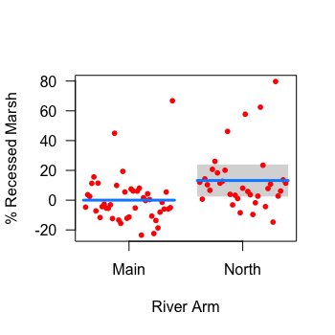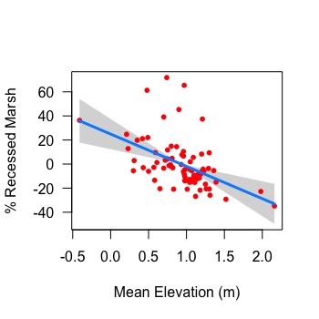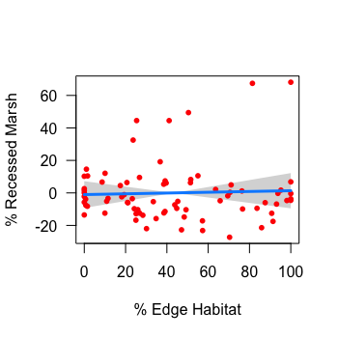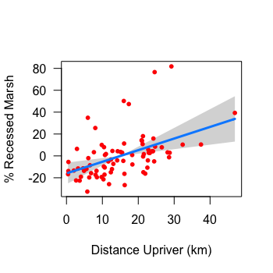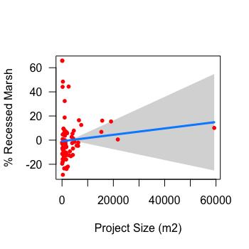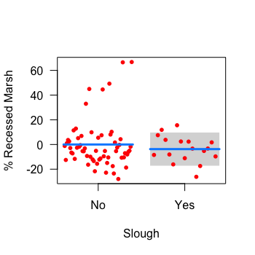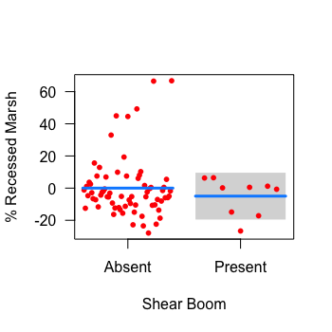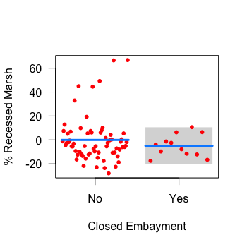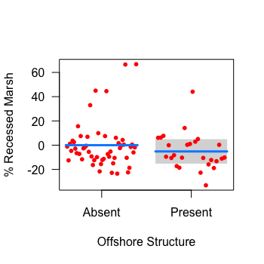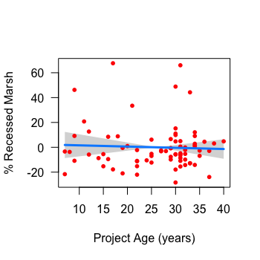

Figure 12. Plots displaying how the expected dependent variable (% recessed marsh) changes as a function of each model predictor (x-axis), while all other model variables are held fixed. The expected value is displayed with the blue line, 95% confidence interval for the expected value with the grey band, and partial residuals with red dots. This and all subsequent plots in Appendices J,M & O were created using visreg package in R (visreg, ‘visreg’ package; Breheny & Burchett 2017)

## Appendix I. Summary Statistics of Native Dominance Model Variables

Table 7. Summary statistics for all variables included in the native dominance model. Continuous data are summarized using minimum, maximum, mean, and standard deviation values, while categorical data show the number and relative frequency of each variable.

|  |  |  |  |  |  |  |
| --- | --- | --- | --- | --- | --- | --- |
|  | **Continuous Data** | | | | **Categorical Data** | |
| *Variable* | *min* | *max* | *mean* | *stdev* | *yes* | *no* |
| Distance upriver (km) | 0.44 | 46.92 | 15.08 | 9.26 | - | - |
| Sampling age (years) | 2 | 37 | 20.61 | 8.34 | - | - |
| Elevation (m) | 0.77 | 2.80 | 0.94 | 0.46 | - | - |
| Channel proximity (m) | 0 | 201.43 | 20.46 | 28.83 | - | - |
| North arm | - | - | - | - | 524 (42%) | 720 (58%) |
| Closed embayment | - | - | - | - | 273 (22%) | 1. 8%) |

## Appendix J. Native Dominance Model Summary Table

Table 8. Model summary for the native dominance model, including model estimates, confidence intervals, *p*-values, number of observations, and *R*2 values.

|  |  |  |  |  |
| --- | --- | --- | --- | --- |
| *Predictors* | *Estimates* | | *CI* | *p* |
| (Intercept) | 84.56 | | 64.03 – 105.10 | **<0.001** |
| Closed embayment [Yes] | -16.16 | | -29.52 – -2.79 | **0.018** |
| River arm [North] | 0.08 | | -10.94 – 11.10 | 0.989 |
| Age at time of sampling (years) | -0.27 | | -0.90 – 0.35 | 0.393 |
| Distance upriver (km) | -1.04 | | -1.89 – -0.18 | **0.017** |
| Plot elevation (m) | -1.14 | | -9.79 – 7.50 | 0.796 |
| Channel proximity (m) | 0.17 | | -0.02 – 0.35 | 0.075 |
| Distance upriver:elevation | 0.16 | | -0.34 – 0.67 | 0.529 |
| Elevation:channel proximity | -0.19 | | -0.35 – -0.03 | **0.018** |
| **Random Effects** | | | | |
| σ2 | 772.89 | | | |
| τ00 SITE | 446.21 | | | |
| τ00 SAMPLE_YEAR | 0.00 | | | |
| ICC | 0.37 | | | |
| N SITE | 79 | | | |
| N SAMPLE_YEAR | 2 | | | |
| Observations | 1244 | | | |
| Marginal R2 / Conditional R2 | 0.083 / 0.419 | | | |
|  | |  | | |

## Appendix K. Native Dominance Model Visualizations

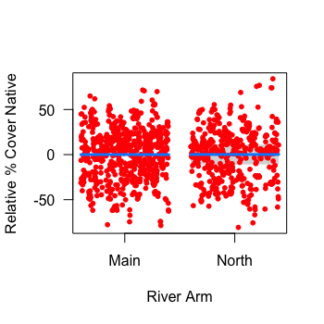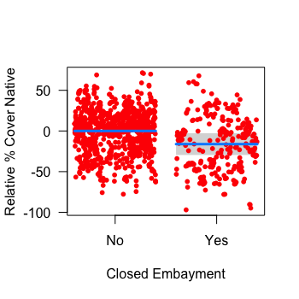

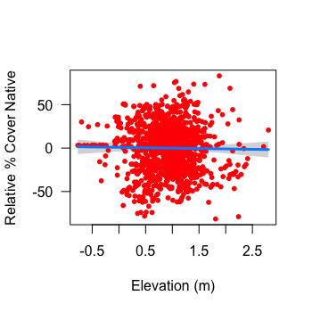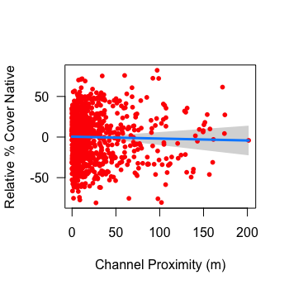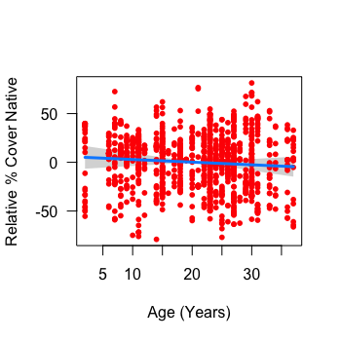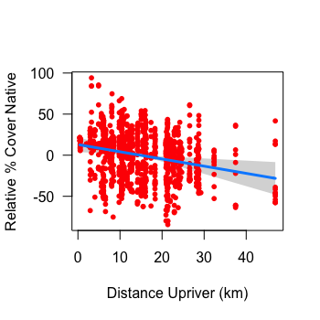

Figure 13. Plots displaying how relative % cover of native species changes as a function of each model predictor (x-axis), while all other model variables are held fixed. The expected value is displayed with the blue line, 95% confidence interval for the expected value with the grey band, and partial residuals with red dots.

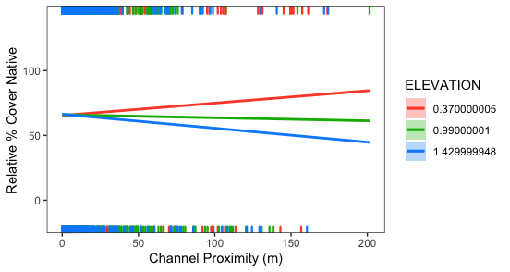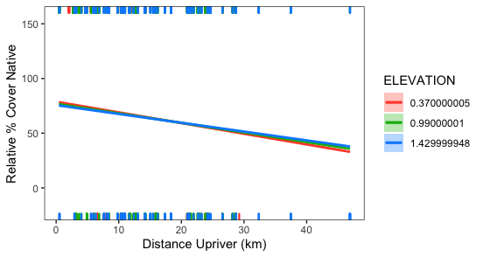

Figure 14. Cross sectional plots displaying the fit of a model with an interaction between % distance upriver and elevation (top) and channel proximity and elevation (bottom) on relative % cover of native species in sample plots. Continuous elevation data are placed into one of three cross-sections: 10th percentile (red), 50th percentile (green), and 90th percentile (blue), and the expected value of each cross-section is displayed by regression lines. Positive and negative residuals are located on the top and bottom axes.

## Appendix L: Summary Statistics of Richness Model Variables

Table 9. Summary statistics for all variables included in the native and non-native richness models. Continuous data are summarized using minimum, maximum, mean, and standard deviation values, while categorical data show the number and relative frequency of each variable.

|  |  |  |  |  |  |  |
| --- | --- | --- | --- | --- | --- | --- |
|  | **Continuous Variable** | | | | **Categorical Variable** | |
| *Variable* | *min* | *max* | *mean* | *stdev* | *yes* | *no* |
| Distance upriver (km) | 0.44 | 46.92 | 14.85 | 9.02 |  |  |
| Elevation (m) | 0.77 | 2.80 | 0.94 | 0.48 |  |  |
| Channel proximity (m) | 0 | 201.43 | 20.46 | 28.83 |  |  |
| North arm | - | - | - | - | 651 (38%) | 1065 (62%) |
| Closed embayment | - | - | - | - | 273 (16%) | 1443 (84%) |
| Reference marsh | - | - | - | - | 472 (28%) | 1443 (72%) |

## Appendix M. Native Richness Model Summary Table

Table 10. Model summary for the native richness model, including model estimates, confidence intervals, *p*-values, number of observations, and *R*2 values.

|  |  |  |  |
| --- | --- | --- | --- |
| *Predictors* | *Estimates* | *CI* | *p* |
| (Intercept) | 2.15 | 0.88 – 3.41 | **0.001** |
| Closed embayment [Yes] | -1.45 | -2.29 – -0.61 | **0.001** |
| River arm [North] | 0.25 | -0.39 – 0.89 | 0.443 |
| Reference site [Yes] | -0.02 | -0.74 – 0.70 | 0.955 |
| Channel proximity (m) | 0.00 | -0.00 – 0.01 | 0.126 |
| Distance upriver (km) | 0.06 | 0.01 – 0.11 | **0.021** |
| Elevation (m) | 0.85 | 0.39 – 1.31 | **<0.001** |
| Distance upriver: elevation | -0.01 | -0.04 – 0.02 | 0.362 |
| **Random Effects** | | | |
| σ2 | 3.52 | | |
| τ00 SITE | 1.67 | | |
| τ00 SAMPLE_YEAR | 0.40 | | |
| ICC | 0.37 | | |
| N SITE | 95 | | |
| N SAMPLE_YEAR | 2 | | |
| Observations | 1716 | | |
| Marginal R2 / Conditional R2 | 0.081 / 0.421 | | |

## Chart, scatter chart Description automatically generatedAppendix N. Native Richness Model Visualizations

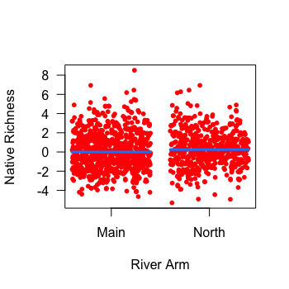

Figure 15. Plots displaying how native richness changes as a function of each model predictor (x-axis), while all other model variables are held fixed. The expected value is displayed with the blue line, 95% confidence interval for the expected value with the grey band, and partial residuals with red dots.

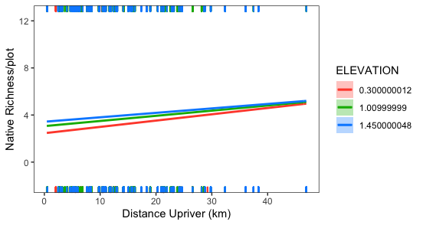

Figure 16. Cross sectional plot displaying the fit of a model with an interaction between % distance upriver and elevation. Continuous elevation data are placed into one of three cross-sections: 10th percentile (red), 50th percentile (green), and 90th percentile (blue). The expected value is displayed by regression lines. Positive and negative residuals are located on the top and bottom axes.

## Appendix O. Non-Native Richness Model Summary Table

Table 11. Summary statistics for all variables included in the non-native richness model. Continuous data are summarized using minimum, maximum, mean, and standard deviation values, while categorical data show the number and relative frequency of each variable.

|  |  |  |  |
| --- | --- | --- | --- |
| *Predictors* | *Estimates* | *CI* | *p* |
| (Intercept) | 0.00 | -0.89 – 0.89 | 0.997 |
| Closed embayment [Yes] | -0.27 | -0.95 – 0.41 | 0.437 |
| River arm [North] | 0.06 | -0.47 – 0.58 | 0.836 |
| Reference site [Yes] | -0.31 | -0.90 – 0.28 | 0.304 |
| Channel proximity (m) | 0.01 | 0.00 – 0.01 | **0.024** |
| Distance upriver (km) | 0.11 | 0.08 – 0.15 | **<0.001** |
| Elevation (m) | 1.43 | 1.08 – 1.78 | **<0.001** |
| Distance upriver:elevation | -0.04 | -0.06 – -0.02 | **<0.001** |
| **Random Effects** | | | |
| σ2 | 1.96 | | |
| τ00 SITE | 1.16 | | |
| τ00 SAMPLE_YEAR | 0.13 | | |
| ICC | 0.40 | | |
| N SITE | 95 | | |
| N SAMPLE_YEAR | 2 | | |
| Observations | 1716 | | |
| Marginal R2 / Conditional R2 | 0.181 / 0.506 | | |

## Appendix P. Non-native Richness Model Visualizations

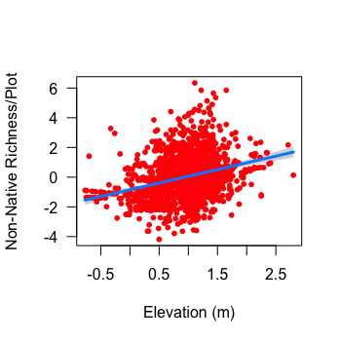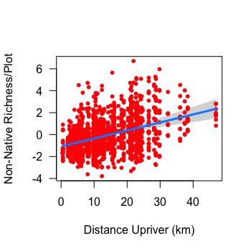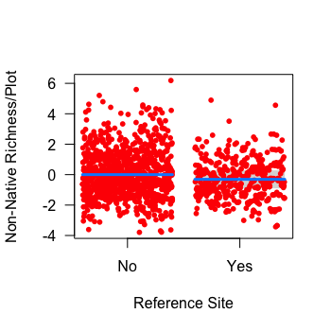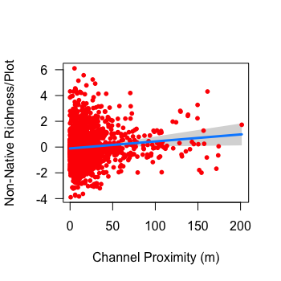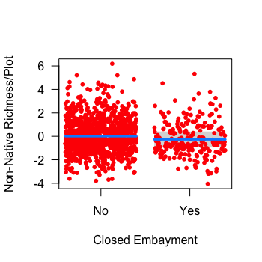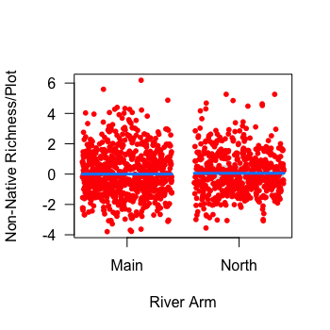

Figure 17. Plots displaying how non-native richness changes as a function of each model predictor (x-axis), while all other model variables are held fixed. The expected value is displayed with the blue line, 95% confidence interval for the expected value with the grey band, and partial residuals with red dots.

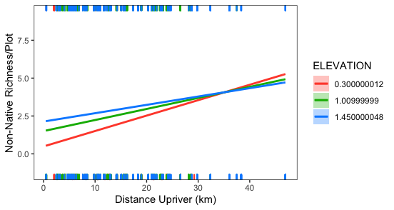

Figure 18. Cross sectional plot displaying the fit of a model with an interaction between % distance upriver and elevation. Continuous elevation data are placed into one of three cross-sections: 10th percentile (red), 50th percentile (green), and 90th percentile (blue). The expected value is displayed by regression lines. Positive and negative residuals are located on the top and bottom axes.

1. According to the Policy these losses could not occur in fish habitats with high productive capacity
2. An alternate version of the model was run that included reference site plot data and had project age removed as a variable. Results were near-identical, with a significant effect of closed embayments, distance upriver and an interaction between channel proximity and elevation. The placement of plots in reference or constructed marshes had no significant effect on native dominance.
3. A recent survey estimated that a minimum of 740 Canada Geese moult in the upper estuary and 1500 at the delta front (Janus 2021, unpublished data)
4. Monitoring periods varied by project, but were often 5 years